## Practical 1(A)

**Aim:**

**Create a application to print on screen the output of addition, subtraction,multiplication,division of two numbers entered by the user in c#**

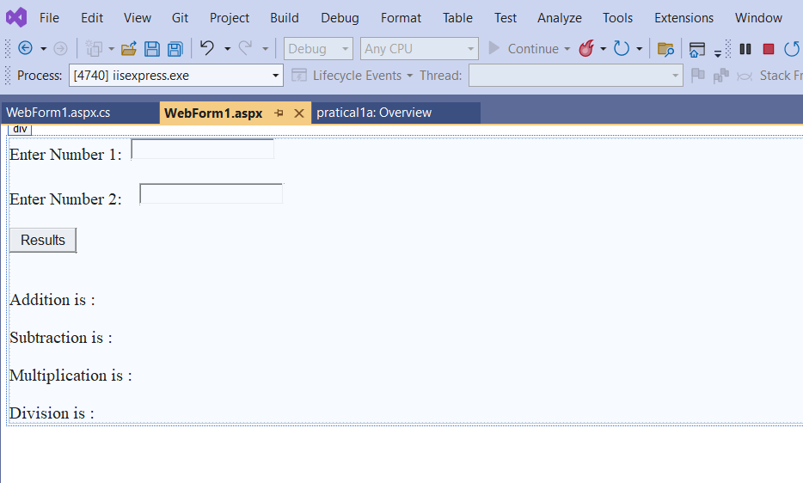

## Default.aspx

<%@ Page Language="C#" AutoEventWireup="true" CodeBehind="WebForm1.aspx.cs" Inherits="pratical1a.WebForm1" %>

<!DOCTYPE html>

<html xmln[s="h](http://www.w3.org/1999/xhtml)ttp[://www.w3.org/1999/xhtml">](http://www.w3.org/1999/xhtml)

<head runat="server">

<title></title>

</head>

<body>

<form id="form1" runat="server">

<div>

<asp:Label ID="Label5" runat="server" Text="Enter Number 1:"></asp:Label> &nbsp;

<asp:TextBox ID="TextBox1" runat="server"></asp:TextBox>

<br />

<br >

<asp:Label ID="Label6" runat="server" Text="Enter Number 2:"></asp:Label>

&nbsp;&nbsp;&nbsp;

<asp:TextBox ID="TextBox2" runat="server"></asp:TextBox>

<br />

<br />

<asp:Button ID="Button1" runat="server" OnClientClick="submit_click" Text="Results" OnClick="Button1_Click" />

<br />

<br />

<br />

<asp:Label ID="Label1" runat="server" Text="Addition is :"></asp:Label>

<br />

<br />

<asp:Label ID="Label2" runat="server" Text="Subtraction is :"></asp:Label>

<br />

<br />

<asp:Label ID="Label3" runat="server" Text="Multiplication is :"></asp:Label>

<br />

<br />

<asp:Label ID="Label4" runat="server" Text="Division is :"></asp:Label>

</div>

</form>

</body>

</html>

## Default.aspx

using System;

using System.Collections.Generic; using System.Linq;

using System.Reflection.Emit; using System.Web;

using System.Web.UI;

using System.Web.UI.WebControls;

namespace pratical1a

{

public partial class WebForm1 : System.Web.UI.Page

{

protected void Page_Load(object sender, EventArgs e)

{

}

protected void Button1_Click(object sender, EventArgs e)

{

int addition, subtraction, multiplication, division;

addition= Convert.ToInt32(TextBox1.Text) + Convert.ToInt32(TextBox2.Text); subtraction = Convert.ToInt32(TextBox1.Text) - Convert.ToInt32(TextBox2.Text); multiplication = Convert.ToInt32(TextBox1.Text) * Convert.ToInt32(TextBox2.Text); division = Convert.ToInt32(TextBox1.Text) / Convert.ToInt32(TextBox2.Text);

Label1.Text = "Addition of the number is: " + addition;

Label2.Text = " Subtraction of the number is: " + subtraction; Label3.Text = "Multiplication of the number is: " + multiplication; Label4.Text = "Division of the number is: " + division;

} } }

**Output:**

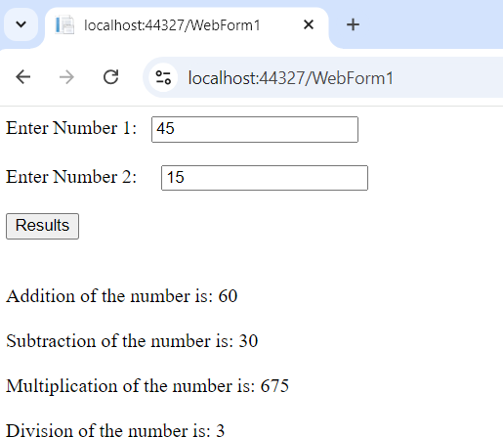

# PRACTICAL1(B)

**Aim:**

**Create a application to print Floyd’s triangle till n rows in C#**

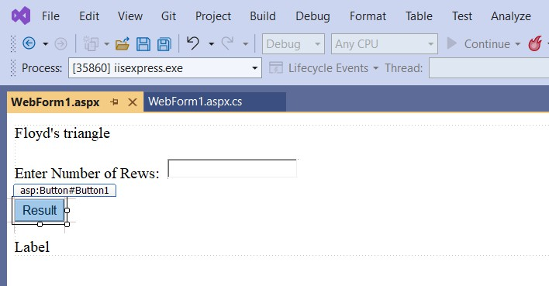

**Default.aspx**

<%@ Page Language="C#" AutoEventWireup="true" CodeBehind="WebForm1.aspx.cs" Inherits="practical1b.WebForm1" %>

<!DOCTYPE html>

<html xmln[s="h](http://www.w3.org/1999/xhtml)ttp[://www.w3.org/1999/xhtml">](http://www.w3.org/1999/xhtml)

<head runat="server">

<title></title>

</head>

<body>

<form id="form1" runat="server">

<div>

<asp:Label ID="Label1" runat="server" Text="Floyd's triangle"></asp:Label>

<br />

<br />

<asp:Label ID="Label2" runat="server" Text="Enter Number of Rews:"></asp:Label> &nbsp;

<asp:TextBox ID="TextBox1" runat="server"></asp:TextBox>

<br />

<br />

<asp:Button ID="Button1" runat="server" OnClientClick="submit_click" Text="Result" OnClick="Button1_Click1" />

<br />

<br />

<asp:Label ID="Label3" runat="server" Text="Label"></asp:Label>

</div>

</form>

</body>

</html>

**Default.aspx.cs**

using System;

using System.Collections.Generic; using System.Linq;

using System.Text; using System.Web; using System.Web.UI;

using System.Web.UI.WebControls; namespace practical1b

{

public partial class WebForm1 : System.Web.UI.Page

{

protected void Page_Load(object sender, EventArgs e)

{

}

protected void Button1_Click1(object sender, EventArgs e)

{

int numOfRows = Convert.ToInt32(TextBox1.Text); int number = 1;

StringBuilder sb = new StringBuilder(); for (int i = 1; i <= numOfRows; i++)

{

for (int j = 1; j <= i; j++)

{

sb.Append(number + " "); number++;

}

sb.Append("<br />");

}

Label1.Text = sb.ToString();

} }}

**Output:**

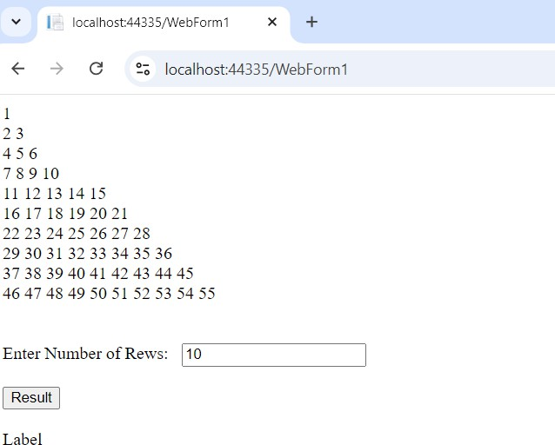

# PRACTICAL1(C)

**Aim:**

**Create a application to demonstrate following operations**

1. **Generate Fibonacci series.**
2. **Test for prime numbers.**

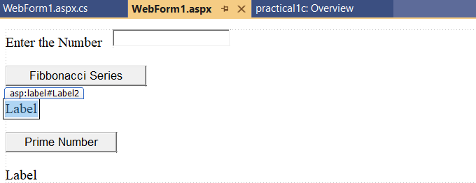

**Default.aspx**

<%@ Page Language="C#" AutoEventWireup="true" CodeBehind="WebForm1.aspx.cs" Inherits="practical1c.WebForm1" %>

<!DOCTYPE html>

<html xmln[s="h](http://www.w3.org/1999/xhtml)ttp[://www.w3.org/1999/xhtml">](http://www.w3.org/1999/xhtml)

<head runat="server">

<title></title>

</head>

<body>

<form id="form1" runat="server">

<div>

<asp:Label ID="Label1" runat="server" Text="Enter the Number"></asp:Label> &nbsp;&nbsp;

<asp:TextBox ID="TextBox1" runat="server"></asp:TextBox>

<br />

<br />

<asp:Button ID="Button1" runat="server" OnClick="Button1_Click" OnClientClick="Submit_click" Text="Fibbonacci Series" />

<br />

<br />

<asp:Label ID="Label2" runat="server" Text="Label"></asp:Label>

<br />

<br />

<asp:Button ID="Button2" runat="server" OnClick="Button2_Click" OnClientClick="Submit_click" Text="Prime Number" />

<br />

<br />

<asp:Label ID="Label3" runat="server" Text="Label"></asp:Label>

</div>

</form>

</body>

</html>

**Default.aspx.cs**

using System;

using System.Collections.Generic; using System.Linq;

using System.Reflection.Emit; using System.Web;

using System.Web.UI;

using System.Web.UI.WebControls;

using static System.Net.Mime.MediaTypeNames;

namespace practical1c

{

public partial class WebForm1 : System.Web.UI.Page

{

protected void Page_Load(object sender, EventArgs e)

{

}

protected void Button1_Click(object sender, EventArgs e)

{

int a, b, c, i, n;

a = 0;

b = 1;

Label2.Text = a.ToString() + b.ToString(); n = Convert.ToInt32(TextBox1.Text);

for (i = 1; i <= n; ++i)

{

c = a + b;

Label2.Text=Label2.Text + c.ToString();

a = b;

b = c;

}

}

protected void Button2_Click(object sender, EventArgs e)

{

int n, i, s = 0;

n = Convert.ToInt32(TextBox1.Text); if (n == 0 || n == 1)

s = 1;

for (i = 2; i <= n / 2; ++i)

{

if (n % i == 0)

{

s = 1;

break;

}

}

if (s == 0)

Label3.Text = "The given number is prime"; else

Label3.Text = "The given number is not prime";

}

}

}

**Output:**

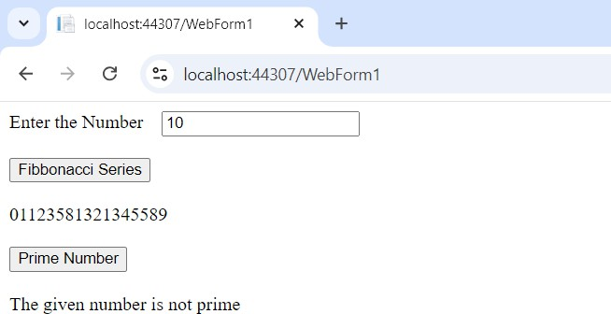

# PRACTICAL 2(A)

**Aim:**

**Create a simple application to demonstrate the concept of boxing and unboxing**

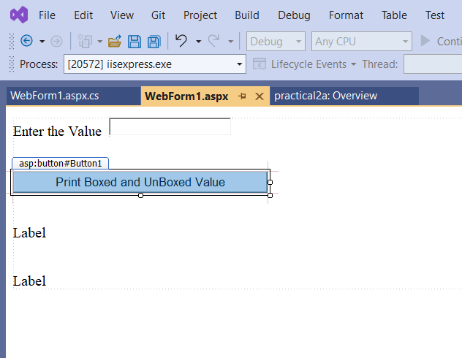

**Pract2.aspx**

<%@ Page Language="C#" AutoEventWireup="true" CodeBehind="WebForm1.aspx.cs" Inherits="practical2a.WebForm1" %>

<!DOCTYPE html>

<html xmln[s="h](http://www.w3.org/1999/xhtml)ttp[://www.w3.org/1999/xhtml">](http://www.w3.org/1999/xhtml)

<head runat="server">

<title></title>

</head>

<body>

<form id="form1" runat="server">

<div>

<asp:Label ID="Label1" runat="server" Text="Enter the Value"></asp:Label> &nbsp;

<asp:TextBox ID="TextBox1" runat="server"></asp:TextBox>

<br />

<br />

<br />

<asp:Button ID="Button1" runat="server" OnClick="Button1_Click" OnClientClick="submit_click" Text="Print Boxed and UnBoxed Value" />

<br />

<br />

<br />

<asp:Label ID="Label2" runat="server" Text="Label"></asp:Label>

<br />

<br />

<br />

<asp:Label ID="Label3" runat="server" Text="Label"></asp:Label>

</div>

</form>

</body>

</html>

**Pract2.aspx.cs**

using System;

using System.Collections.Generic; using System.Linq;

using System.Runtime.CompilerServices; using System.Web;

using System.Web.UI;

using System.Web.UI.WebControls; namespace practical2a

{

public partial class WebForm1 : System.Web.UI.Page

{

protected void Page_Load(object sender, EventArgs e)

{

}

protected void Button1_Click(object sender, EventArgs e)

{

int valueType = Convert.ToInt32(TextBox1.Text); object boxed = valueType;

Label2.Text = "Boxed Value:" + boxed; int unboxed = (int)boxed;

Label3.Text = "unboxed value:" + unboxed;

}

}

}

**Output:**

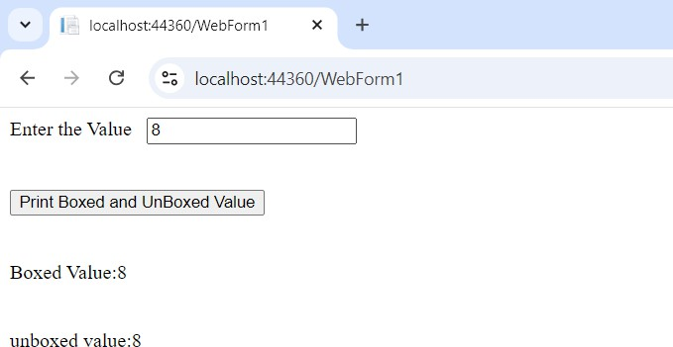

## Practical 2(B)

**Aim:**

**Create a simple application to perform addition and subtraction using delegate**

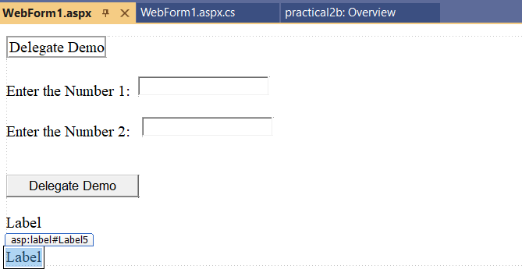

**Pract2b.aspx**

<%@ Page Language="C#" AutoEventWireup="true" CodeBehind="WebForm1.aspx.cs" Inherits="practical2b.WebForm1" %>

<!DOCTYPE html>

<html xmln[s="h](http://www.w3.org/1999/xhtml)ttp[://www.w3.org/1999/xhtml">](http://www.w3.org/1999/xhtml)

<head runat="server">

<title></title>

</head>

<body>

<form id="form1" runat="server">

<div>

<asp:Label ID="Label1" runat="server" BorderStyle="Groove" Text="Delegate Demo"></asp:Label>

<br />

<br />

<asp:Label ID="Label2" runat="server" Text="Enter the Number 1:"></asp:Label> &nbsp;

<asp:TextBox ID="TextBox1" runat="server"></asp:TextBox>

<br />

<br />

<asp:Label ID="Label3" runat="server" Text="Enter the Number 2:"></asp:Label> &nbsp;&nbsp;

<asp:TextBox ID="TextBox2" runat="server"></asp:TextBox>

<br />

<br />

<br />

<asp:Button ID="Button1" runat="server" OnClick="Button1_Click" Text="Delegate Demo" />

<br />

<br />

<asp:Label ID="Label4" runat="server" Text="Label"></asp:Label>

<br />

<br />

<asp:Label ID="Label5" runat="server" Text="Label"></asp:Label>

</div>

</form>

</body>

</html>

**Pract2b.aspx.cs**

using System;

using System.Collections.Generic; using System.Linq;

using System.Reflection.Emit; using System.Web;

using System.Web.UI;

using System.Web.UI.WebControls;

namespace practical2b

{

public delegate int MathOperation(int a, int b);

public partial class WebForm1 : System.Web.UI.Page

{

int Add(int a, int b)

{

return a + b;

}

int Subtract(int a, int b)

{

return a - b;

}

protected void Button1_Click(object sender, EventArgs e)

{

int x = Convert.ToInt32(TextBox1.Text); int y = Convert.ToInt32(TextBox2.Text);

MathOperation add = new MathOperation(Add); MathOperation subtract = new MathOperation(Subtract); Label4.Text = add(x, y).ToString();

Label5.Text = subtract(x, y).ToString();

}

}

}

**Output:**

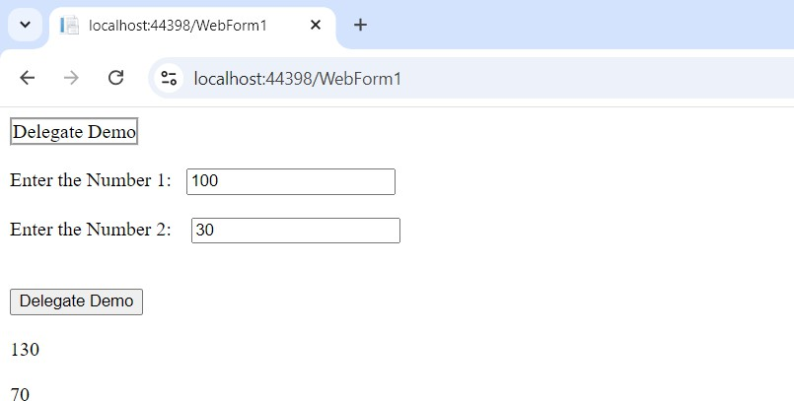

## Practical 2(C)

**Aim:**

**Create a simple application to demonstrate use of the concept of interfaces.**

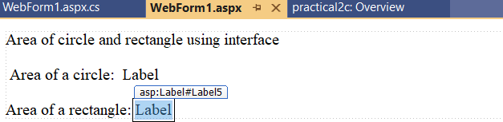

**Pract2c.aspx**

<%@ Page Language="C#" AutoEventWireup="true" CodeBehind="WebForm1.aspx.cs" Inherits="practical2c.WebForm1" %>

<!DOCTYPE html>

<html xmln[s="h](http://www.w3.org/1999/xhtml)ttp[://www.w3.org/1999/xhtml">](http://www.w3.org/1999/xhtml)

<head runat="server">

<title></title>

</head>

<body>

<form id="form1" runat="server">

<div>

<asp:Label ID="Label1" runat="server" Text="Area of circle and rectangle using interface"></asp:Label>

<br /><br />

&nbsp;<asp:Label ID="Label2" runat="server" Text="Area of a circle:"></asp:Label> &nbsp;

<asp:Label ID="Label3" runat="server" Text="Label"></asp:Label>

<br /><br />

<asp:Label ID="Label4" runat="server" Text="Area of a rectangle:"></asp:Label>

&nbsp;<asp:Label ID="Label5" runat="server" Text="Label"></asp:Label>

</div>

</form>

</body>

</html>

**Pract2c.aspx.cs**

using System;

using System.Collections.Generic; using System.Linq;

using System.Web; using System.Web.UI;

using System.Web.UI.WebControls;

namespace practical2c

{

interface Area

{

double show(double s, double t);

}

class Rect : Area

{

public double show(double s, double t)

{

return s*t;

}

}

class Circle : Area

{

public double show(double s, double t)

{

return (3.14 * s * s);

}

}

public partial class WebForm1 : System.Web.UI.Page

{

protected void Page_Load(object sender, EventArgs e)

{

Rect r1 = new Rect(); double x=r1.show(3, 4); Circle c1 = new Circle(); double y=c1.show(3, 4); Label3.Text = x.ToString();

Label5.Text =y.ToString();

}

}

}

**Output:**

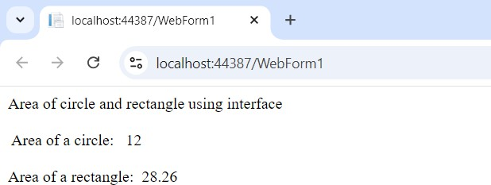

## Practical 3(A)

**Aim:**

**Create a simple web page with various server controls to demonstrate setting and use of their properties. (example AutoPostBack)**

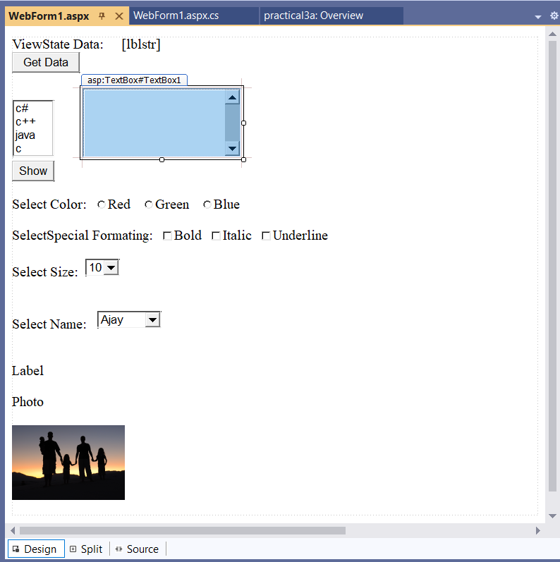

**Pract3a.aspx**

<%@ Page Language="C#" AutoEventWireup="true" CodeBehind="WebForm1.aspx.cs" Inherits="practical3a.WebForm1" %>

<!DOCTYPE html>

<html xmln[s="h](http://www.w3.org/1999/xhtml)ttp[://www.w3.org/1999/xhtml">](http://www.w3.org/1999/xhtml)

<head runat="server">

<title></title>

</head>

<body>

<form id="form1" runat="server">

<div>

<asp:Label ID="Label1" runat="server" Text="ViewState Data:"></asp:Label> &nbsp;

&nbsp;&nbsp;

<asp:Label ID="lblstr" runat="server"></asp:Label>

<br />

<asp:Button ID="Button1" runat="server" OnClick="Button1_Click" Text="Get Data" />

<br />

<br />

<asp:ListBox ID="ListBox1" runat="server" OnSelectedIndexChanged="ListBox1_SelectedIndexChanged1" AutoPostBack="True" SelectionMode="Multiple" DataTextField="multiple">

<asp:ListItem>c#</asp:ListItem>

<asp:ListItem Value="c++"></asp:ListItem>

<asp:ListItem Value="java"></asp:ListItem>

<asp:ListItem>c</asp:ListItem>

</asp:ListBox> &nbsp;&nbsp;&nbsp;&nbsp;&nbsp;&nbsp;&nbsp;

<asp:TextBox ID="TextBox1" runat="server" Height="92px" style="margin-top: 0px" TextMode="MultiLine" AutoPostBack="True"></asp:TextBox>

<br />

<asp:Button ID="Button2" runat="server" OnClick="Button2_Click" Text="Show" />

<br />

<br />

<asp:Label ID="Label2" runat="server" Text="Select Color:"></asp:Label> &nbsp;

<asp:RadioButton ID="RadioButton1" runat="server"

OnCheckedChanged="RadioButton1_CheckedChanged" Text="Red" /> &nbsp;&nbsp;

<asp:RadioButton ID="RadioButton2" runat="server"

OnCheckedChanged="RadioButton2_CheckedChanged" Text="Green" />

&nbsp;&nbsp;

<asp:RadioButton ID="RadioButton3" runat="server"

OnCheckedChanged="RadioButton3_CheckedChanged" Text="Blue" />

<br />

<br />

<asp:Label ID="Label3" runat="server" Text="SelectSpecial Formating:"></asp:Label> &nbsp;

<asp:CheckBox ID="CheckBox1" runat="server" OnCheckedChanged="CheckBox1_CheckedChanged" Text="Bold" />

&nbsp;

<asp:CheckBox ID="CheckBox2" runat="server" OnCheckedChanged="CheckBox2_CheckedChanged" Text="Italic" />

&nbsp;

<asp:CheckBox ID="CheckBox3" runat="server" OnCheckedChanged="CheckBox3_CheckedChanged" Text="Underline" />

<br />

<br />

<asp:Label ID="Label4" runat="server" Text="Select Size:"></asp:Label> &nbsp;

<asp:DropDownList ID="DropDownList1" runat="server" AutoPostBack="True" OnSelectedIndexChanged="DropDownList1_SelectedIndexChanged">

<asp:ListItem>10</asp:ListItem>

<asp:ListItem>20</asp:ListItem>

<asp:ListItem>30</asp:ListItem>

<asp:ListItem>40</asp:ListItem>

<asp:ListItem>50</asp:ListItem>

</asp:DropDownList>

<br />

<br /> &nbsp;<br />

<asp:Label ID="Label5" runat="server" Text="Select Name:"></asp:Label> &nbsp;&nbsp;

<asp:DropDownList ID="DropDownList2" runat="server" AutoPostBack="True" OnSelectedIndexChanged="DropDownList2_SelectedIndexChanged">

<asp:ListItem>Ajay</asp:ListItem>

<asp:ListItem>Aditya</asp:ListItem>

<asp:ListItem>Anand</asp:ListItem>

<asp:ListItem>Shiv</asp:ListItem>

<asp:ListItem>Saurav</asp:ListItem>

<asp:ListItem>Kartikya</asp:ListItem>

</asp:DropDownList>

<br />

<br />

<br />

<asp:Label ID="Label6" runat="server" Text="Label"></asp:Label>

<br />

<asp:Label ID="Label7" runat="server" Text="Photo"></asp:Label>

<br />

<br />

<asp:Image ID="Image1" runat="server"

ImageUrl="https://upload.wikimedia.org/wikipedia/commons/d/df/Family_Portrait.jpg" Width="160px" />

<br />

<br />

</div>

</form>

</body>

</html>

**Pract3a.aspx.cs**

using System;

using System.Collections.Generic; using System.Linq;

using System.Reflection.Emit; using System.Web;

using System.Web.UI;

using System.Web.UI.WebControls;

namespace practical3a

{

public partial class WebForm1 : System.Web.UI.Page

{

protected void Page_Load(object sender, EventArgs e)

{

if (!IsPostBack)

{

string str = "Ajay";

if (ViewState["name"] == null)

{

ViewState["name"] = str;

}

}

}

protected void Button1_Click(object sender, EventArgs e)

{

lblstr.Text = ViewState["name"].ToString();

}

protected void Button2_Click(object sender, EventArgs e)

{

TextBox1.Text = "";

for (int i = 0; i < ListBox1.Items.Count;i++)

{

if (ListBox1.Items[i].Selected == true)

{

TextBox1.Text = TextBox1.Text + "" + ListBox1.Items[i].Text + "\n";

}

}

}

protected void DropDownList1_SelectedIndexChanged(object sender, EventArgs e)

lblstr.Font.Size = int.Parse(DropDownList1.SelectedItem.Text);

}

protected void DropDownList2_SelectedIndexChanged(object sender, EventArgs e)

{

lblstr.Text = DropDownList2.SelectedItem.Text;

}

protected void RadioButton1_CheckedChanged(object sender, EventArgs e)

{

lblstr.BackColor = System.Drawing.Color.Red;

}

protected void RadioButton2_CheckedChanged(object sender, EventArgs e)

{

lblstr.BackColor = System.Drawing.Color.Green;

}

protected void RadioButton3_CheckedChanged(object sender, EventArgs e)

{

lblstr.BackColor = System.Drawing.Color.Blue;

}

protected void CheckBox1_CheckedChanged(object sender, EventArgs e)

{

lblstr.Font.Bold = true;

}

protected void CheckBox2_CheckedChanged(object sender, EventArgs e)

{

lblstr.Font.Italic = true;

}

protected void CheckBox3_CheckedChanged(object sender, EventArgs e)

{

lblstr.Font.Underline = true;

}

}

}

**Output:**

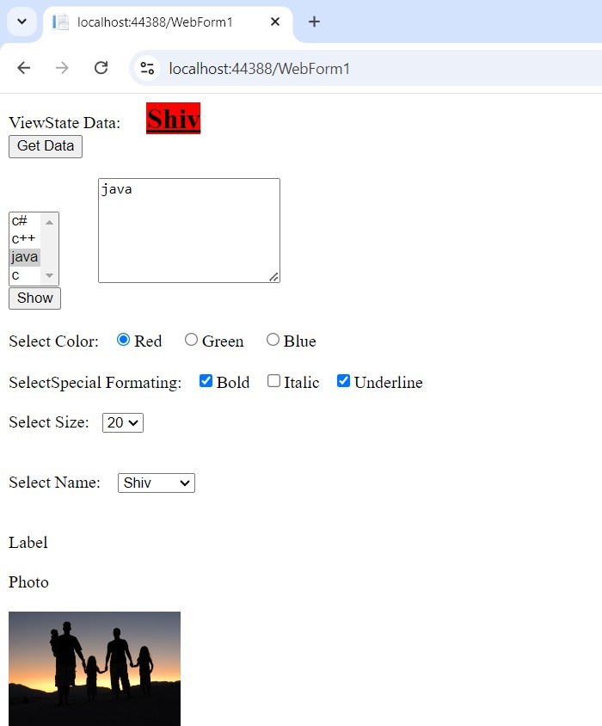

**----------------------------------------------------------------------------------------------------------------------------------------------**

## Practical 3(B)

**Aim:**

**Create a simple application to demonstrate your vacation using callender control.**

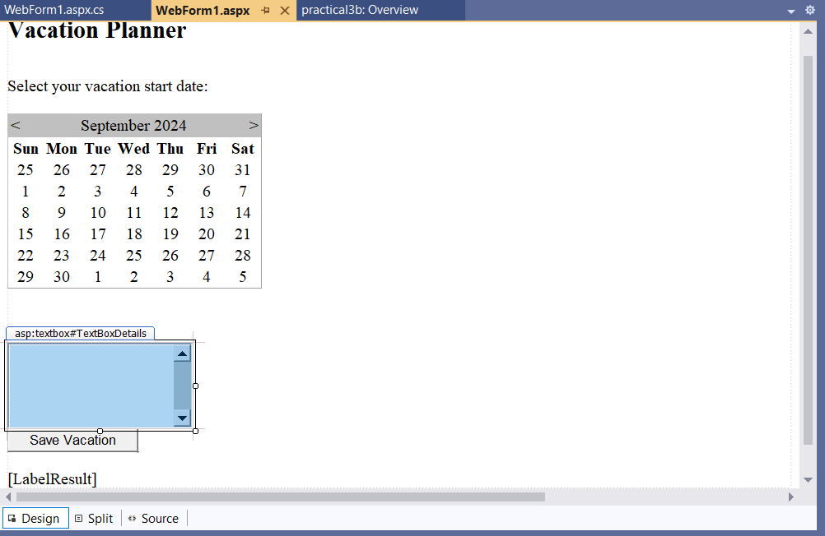

**Pract3b.aspx**

<%@ Page Language="C#" AutoEventWireup="true" CodeBehind="WebForm1.aspx.cs" Inherits="practical3b.WebForm1" %>

<!DOCTYPE html>

<html xmln[s="h](http://www.w3.org/1999/xhtml)ttp[://www.w3.org/1999/xhtml">](http://www.w3.org/1999/xhtml)

<head runat="server">

<title></title>

</head>

<body>

<form id="form1" runat="server">

<div>

<h2> Vacation Planner</h2>

<br />

<asp:Label ID="Label1" runat="server" Text="Select your vacation start date:"></asp:Label>

<br />

<br />

<asp:Calendar ID="Calendar1" runat="server"

OnSelectionChanged="Calender1_SelectionChanged"></asp:Calendar>

<br />

<br />

<asp:Label ID="Label2" runat="server" Text="Vacation Details:"></asp:Label>

<br />

<asp:TextBox ID="TextBoxDetails" runat="server" Rows="5" TextMode="MultiLine"></asp:TextBox>

<br />

<asp:Button ID="Button1" runat="server" OnClick="Button1_Click" Text="Save Vacation" />

<br />

<br />

<asp:Label ID="LabelResult" runat="server"></asp:Label>

</div>

</form>

</body>

</html>

**Pract3b.aspx.cs**

using Antlr.Runtime.Misc; using System;

using System.Collections.Generic; using System.Linq;

using System.Web; using System.Web.UI;

using System.Web.UI.WebControls;

namespace practical3b

{

public partial class WebForm1 : System.Web.UI.Page

{

protected void Page_Load(object sender, EventArgs e)

{

}

protected void Calender1_SelectionChanged(object sender, EventArgs e)

{

LabelResult.Text = "You selected:" + Calendar1.SelectedDate.ToShortDateString();

}

protected void Button1_Click(object sender, EventArgs e)

{

string vacationDate = Calendar1.SelectedDate.ToShortDateString(); string vacationDetails = TextBoxDetails.Text;

if (string.IsNullOrEmpty(vacationDetails))

{

LabelResult.Text = "Please enter vacation details.";

}

else

{

LabelResult.Text = $"Vacation on {vacationDate}:{vacationDetails}";

} } } }

**Output:**

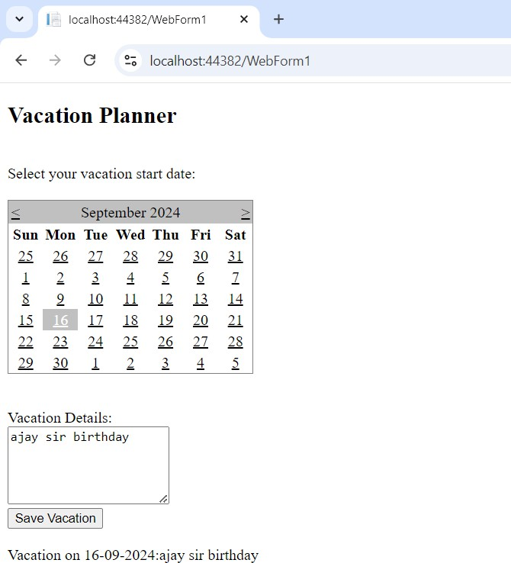

**----------------------------------------------------------------------------------------------------------------------------------------------**

## Practical 3(C)

**Aim:**

**Demonstrate the use of treeview operations on the web form.**

## Step1:

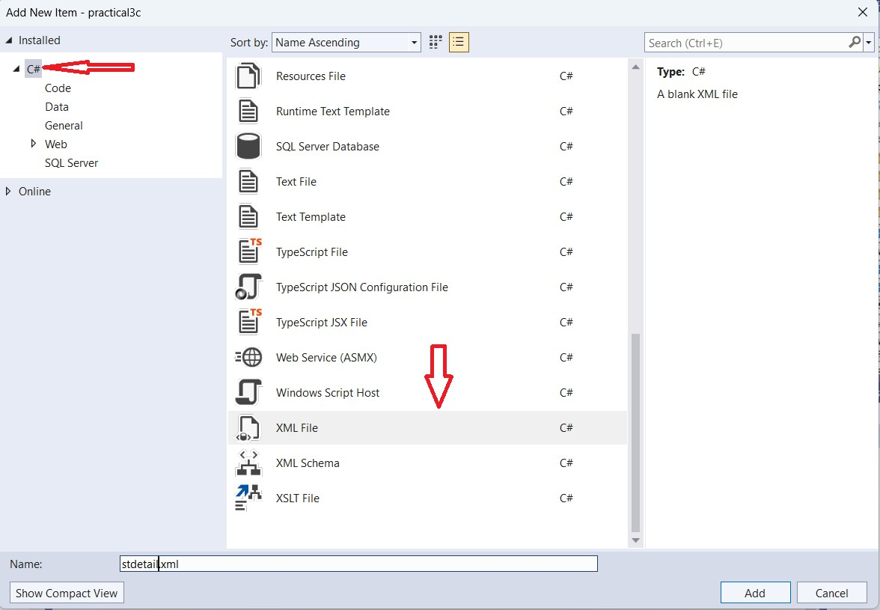

**Stdetail.xml:**

<?xml version="1.0" encoding="utf-8" ?>

<studentdetail>

<student>

<sid>1</sid>

<sname>Saurav</sname>

<sclass>TYIT</sclass>

</student>

<student>

<sid>2</sid>

<sname>Anand</sname>

<sclass>TYCS</sclass>

</student>

<student>

<sid>3</sid>

<sname>Aditya</sname>

</studentdetail>

## Step2:

<sclass>TYIT</sclass>

</student>

<student>

<sid>4</sid>

<sname>Shiv</sname>

<sclass>TYCS</sclass>

</student>

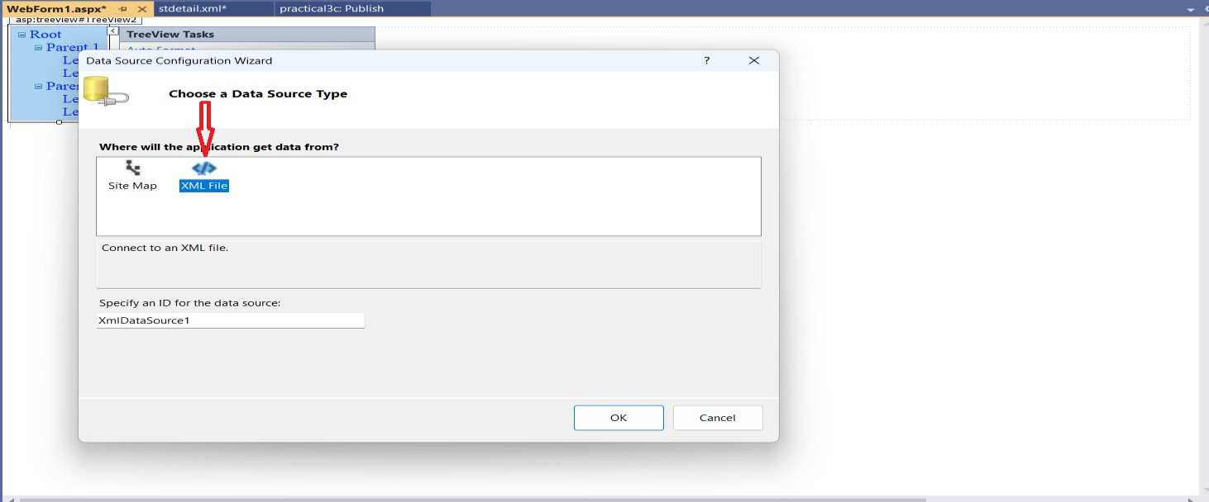

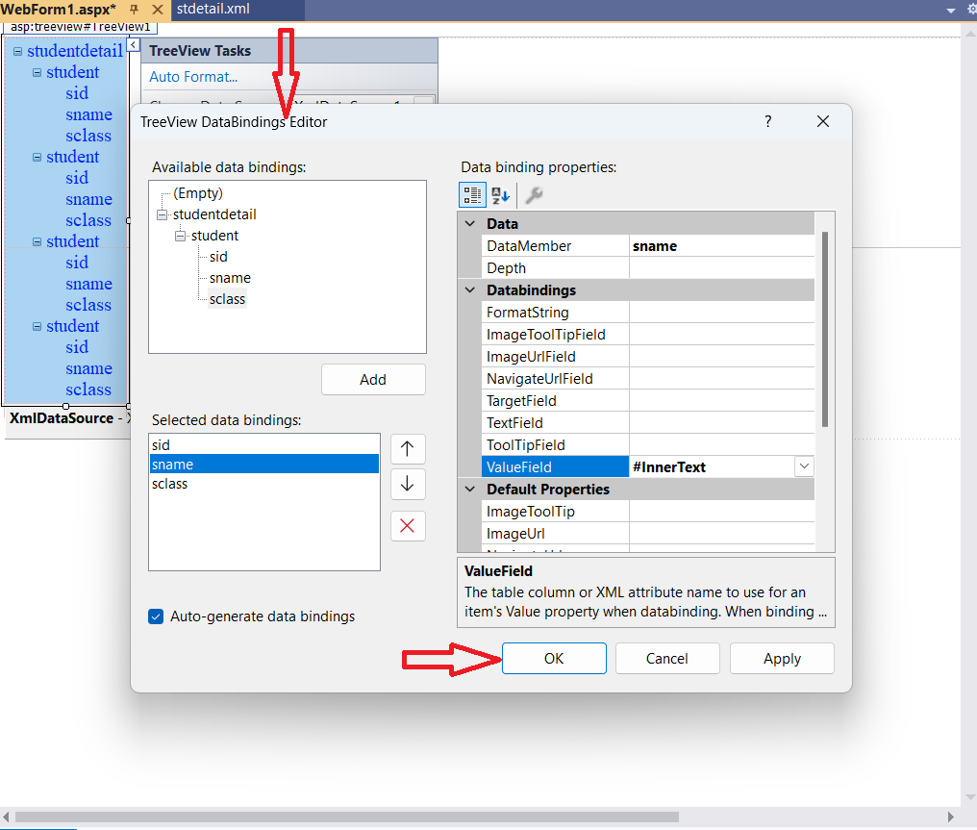

**Pract3c.aspx:**

<%@ Page Language="C#" AutoEventWireup="true" CodeBehind="WebForm1.aspx.cs" Inherits="practical3c.WebForm1" %>

<!DOCTYPE html>

<html xmln[s="h](http://www.w3.org/1999/xhtml)ttp[://www.w3.org/1999/xhtml">](http://www.w3.org/1999/xhtml)

<head runat="server">

<title></title>

</head>

<body style="z-index: 1; width: 1387px; height: 218px; position: absolute; top: 0px; left: 0px">

<form id="form1" runat="server">

<div>

<asp:TreeView ID="TreeView1" runat="server" DataSourceID="XmlDataSource1">

<DataBindings>

<asp:TreeNodeBinding DataMember="sid" ValueField="#InnerText" />

<asp:TreeNodeBinding DataMember="sname" ValueField="#InnerText" />

<asp:TreeNodeBinding DataMember="sclass" ValueField="#InnerText" />

</DataBindings>

</asp:TreeView>

<asp:XmlDataSource ID="XmlDataSource1" runat="server" DataFile="~/stdetail.xml"></asp:XmlDataSource>

</div>

</form>

</body>

</html>

**Pract3c.aspx.cs:**

using System;

using System.Collections.Generic; using System.Linq;

using System.Web; using System.Web.UI;

using System.Web.UI.WebControls;

namespace practical3c

{

public partial class WebForm1 : System.Web.UI.Page

{

protected void Page_Load(object sender, EventArgs e)

{

}

}

}

**Output:**

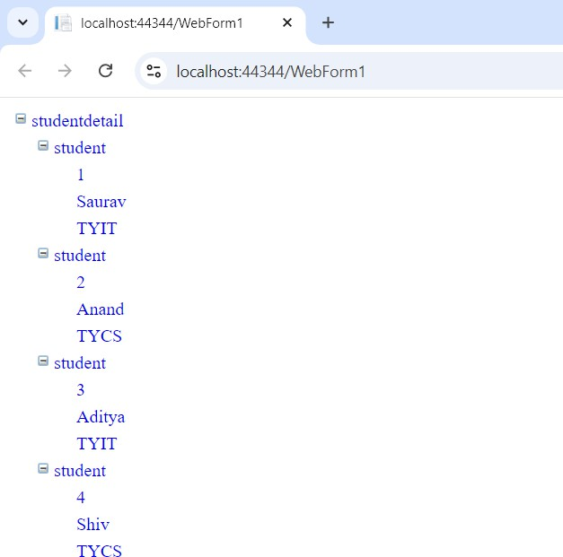

## Practical 4(A)

**Aim:**

**Create a Registration form to demonstrate use of various validation controls.**

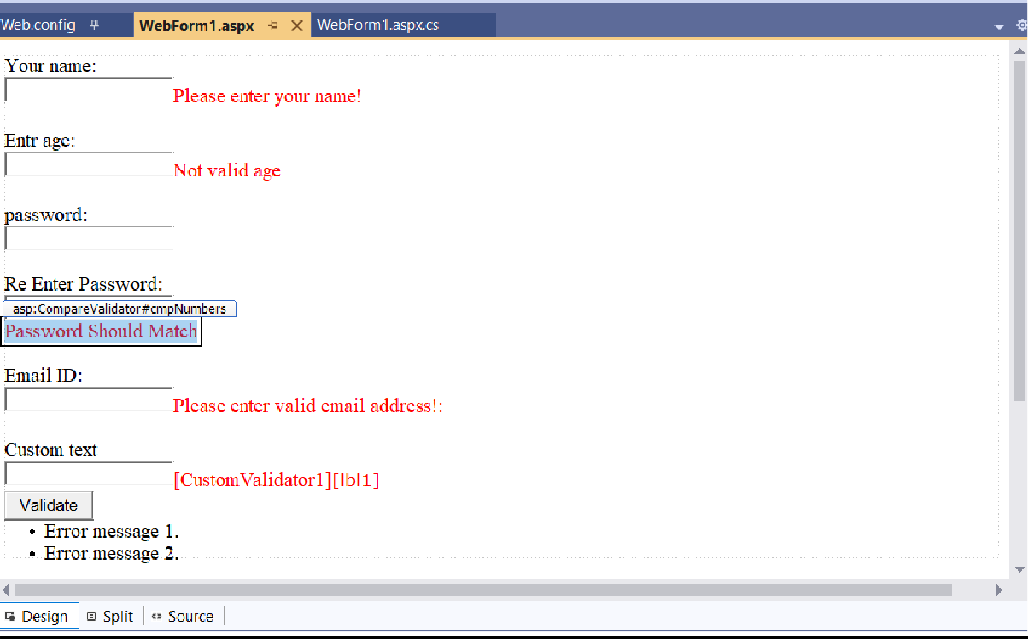

**Default.aspx:**

<%@ Page Language="C#" AutoEventWireup="true" CodeBehind="WebForm1.aspx.cs" Inherits="practical4a.WebForm1" %>

<!DOCTYPE html>

<html xmln[s="h](http://www.w3.org/1999/xhtml)ttp[://www.w3.org/1999/xhtml">](http://www.w3.org/1999/xhtml)

<head runat="server">

<title></title>

<script runat="server">

void ValidateBtn_OnClick(object sender, EventArgs e)

{

if (Page.IsValid)

{

lbl1.Text = "Thank You!";

}

else

{

lbl1.Text = "The text must be exactly 8 characters long!";

}

}

void ServerValidation (object source, ServerValidateEventArgs e)

{

}

</script>

if (e.Value.Length == 8) e.IsValid =true;

else

e.IsValid = false;

<script type="text/javascript"> function ValidateBtn_OnClick() {

// Optionally add client-side validation logic here

return true; // Return false to prevent postback if validation fails }

</script>

</head>

<body>

<form id="form1" runat="server">

<div>

<asp:Label ID="Label1" runat="server" Text="Your name:"></asp:Label>

<br />

<asp:TextBox ID="txtName" runat="server"></asp:TextBox>

<asp:RequiredFieldValidator ID="reqName" runat="server" ControlToValidate="txtName" ErrorMessage="Please enter your name!" ForeColor="Red"></asp:RequiredFieldValidator>

<br />

<br />

<asp:Label ID="Label2" runat="server" Text="Entr age:"></asp:Label>

<br />

<asp:TextBox ID="txt1" runat="server"></asp:TextBox>

<asp:RangeValidator ID="RangeValidator1" runat="server" ControlToValidate="txt1" ErrorMessage="Not valid age" ForeColor="Red" MinimumValue="18" SetFocusOnError="True" MaximumValue="18"

></asp:RangeValidator>

<br />

<asp:Label ID="Label3" runat="server" Text="password:"></asp:Label>

<br />

<asp:TextBox ID="txt11" runat="server" TextMode="Password"></asp:TextBox>

<br />

<asp:Label ID="Label4" runat="server" Text="Re Enter Password:"></asp:Label>

<br />

<asp:TextBox ID="txt12" runat="server" TextMode="Password"></asp:TextBox>

<br />

<asp:CompareValidator ID="cmpNumbers" runat="server" ControlToCompare="txt11" ControlToValidate="txt12" ErrorMessage="Password should match!:" ForeColor="Red" Operator="LessThan" Type="Integer">Password Should Match</asp:CompareValidator>

<br />

<br />

Email ID:<br />

<asp:TextBox ID="txtNumber" runat="server"></asp:TextBox>

<asp:RegularExpressionValidator ID="rexNumber" runat="server" ControlToValidate="txtNumber"

ErrorMessage="Please enter valid email address!: " ForeColor="Red" ValidationExpression="http(s)?://([\w-

]+\.)+[\w-]+(/[\w- ./?%&amp;=]*)?"></asp:RegularExpressionValidator>

<br />

<asp:Label ID="Label5" runat="server" Text="Custom text"></asp:Label>

<br />

<asp:TextBox ID="txtCustom" runat="server"></asp:TextBox>

<asp:CustomValidator ID="CustomValidator1" runat="server" ClientValidationFunction="ServerValidation" ControlToValidate="txtCustom" ForeColor="Red"></asp:CustomValidator>

<asp:Label ID="lbl1" runat="server" Font-Names="Verdana" Font-Size="10pt" ForeColor="Red"></asp:Label>

<br />

<asp:Button ID="Button1" runat="server" OnClick="Button1_Click" OnClientClick="ValidateBtn_OnClick" Text="Validate" />

<br />

<asp:ValidationSummary ID="ValidationSummary1" runat="server" Height="38px" Width="625px" />

</div>

</form>

</body>

</html>

**Web.config:**

<?xml version="1.0" encoding="utf-8"?>

<!-- For more information on how to configure your ASP.NET application, please visit https://go.microsoft.com/fwlink/?LinkId=169433 -->

<configuration>

<appSettings>

<add key="ValidationSettings:UnobtrusiveValidationMode" value="None" />

</appSettings>

<system.web>

<compilation debug="true" targetFramework="4.5.2" />

<httpRuntime targetFramework="4.5.2" />

</system.web>

<system.codedom>

</configuration>

**Output:**

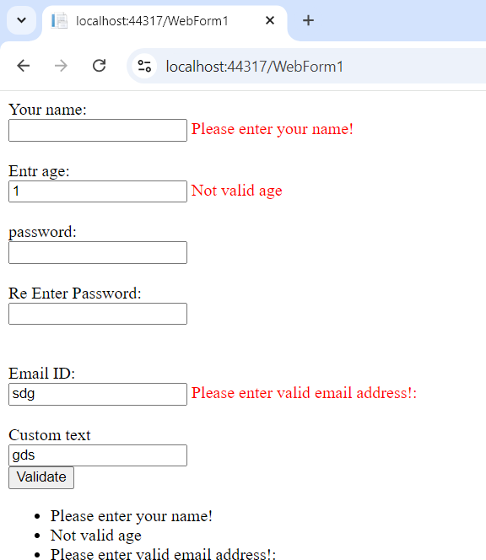

**--------------------------------------------------------------------------------------------------------------------------------------------**

## Practical 4(B)

**Aim:**

**Create a web form to demonstrate use ofAdrotatorControl.**

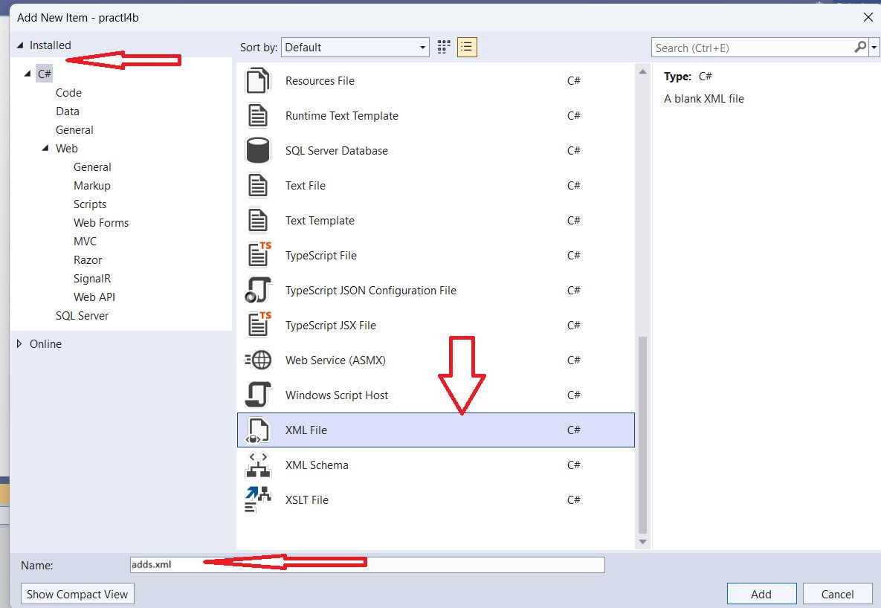

**Pract4b.aspx**

<%@ Page Language="C#" AutoEventWireup="true" CodeBehind="WebForm1.aspx.cs" Inherits="practl4b.WebForm1" %>

<!DOCTYPE html>

<html xmln[s="h](http://www.w3.org/1999/xhtml)ttp[://www.w3.org/1999/xhtml">](http://www.w3.org/1999/xhtml)

<head runat="server">

<title></title>

</head>

<body>

<form id="form1" runat="server">

<div>

</div>

<asp:ScriptManager ID="ScriptManager1" runat="server">

</asp:ScriptManager>

<br />

<asp:Timer ID="Timer1" runat="server" Interval="2000">

</asp:Timer>

<br />

<asp:UpdatePanel ID="UpdatePanel1" runat="server">

<Triggers>

<asp:AsyncPostBackTrigger ControlID="Timer1" EventName="Tick">

</asp:AsyncPostBackTrigger>

</Triggers>

<ContentTemplate>

<asp:AdRotator ID="AdRotator1" runat="server" AdvertisementFile="~/adds.xml" Height="200px" Width="200px" />

</ContentTemplate>

</asp:UpdatePanel>

</form>

</body>

</html>

**adds.xml:**

<?xml version="1.0" encoding="utf-8" ?>

<Advertisements>

<Ad>

<ImageUrl>https://assets.unileversolutions.com/v1/37335556.png?im=AspectCrop=(6 40,640);Resize=(640,640)</ImageUrl>

<NavigateUrl>[http://www.dove.com](http://www.dove.com/)</NavigateUrl>

<AlternateText>Example Ad 1</AlternateText>

</Ad>

<Ad>

<ImageUrl>https://[www.jiomart.com/images/product/original/490819030/cinthol-](http://www.jiomart.com/images/product/original/490819030/cinthol-) lime-refreshing-deo-soap-100-g-buy-4-get-1-free-product-images-o490819030-p490819030-0-

202203150113.jpg?im=Resize=(1000,1000)</ImageUrl>

<NavigateUrl>[http://www.jiomart.com](http://www.jiomart.com/)</NavigateUrl>

</Advertisements>

**Output:**

<AlternateText>Example Ad 2</AlternateText>

</Ad>

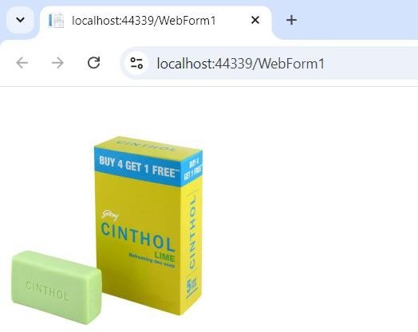

## Practical 4(C)

**Aim:**

**Create web form to demonstrate use User controls.**

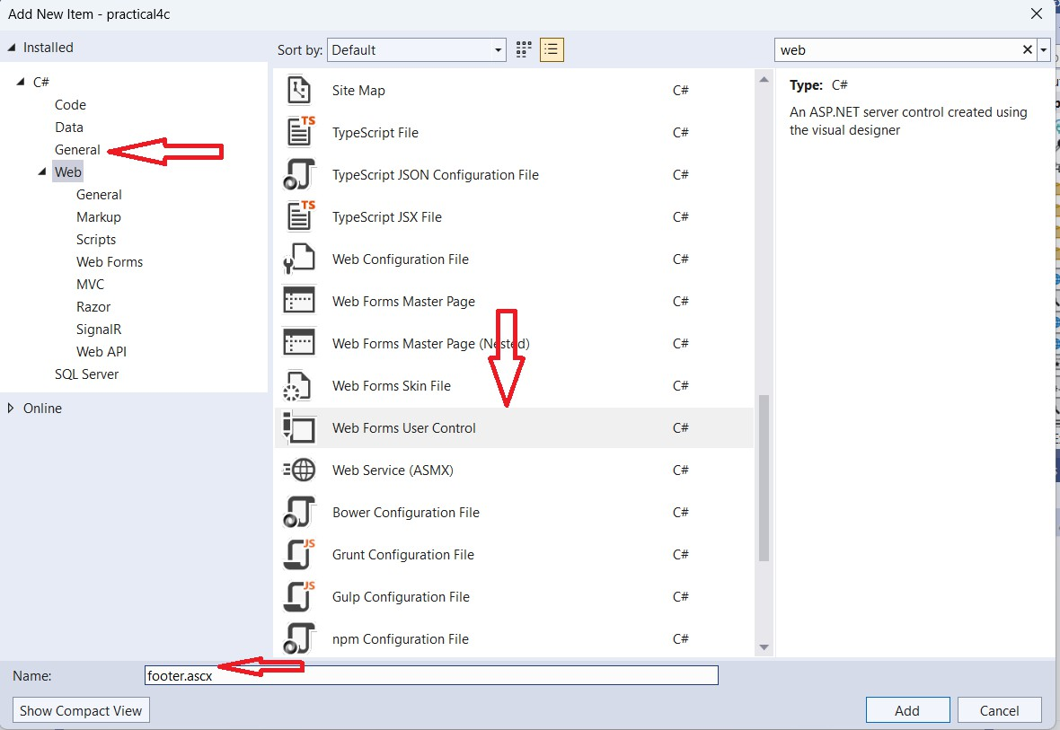

**Footer.ascx**

<%@ Control Language="C#" AutoEventWireup="true" CodeBehind="footer.ascx.cs" Inherits="practical4c.footer" %>

<table>

<tr>

<td align="center" style="font-family: Cambria; background-color: #00CCFF font-size: 14px; text-decoration: blink; color: #FF0000; font-weight: bold;"> Advanced Web programming by Sambare</td>

</tr>

</table>

**Pract4c.aspx**

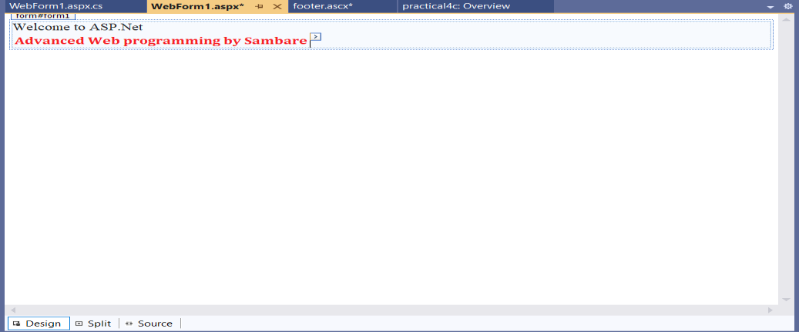

<%@ Page Language="C#" AutoEventWireup="true" CodeBehind="WebForm1.aspx.cs" Inherits="practical4c.WebForm1" %>

<%@ Register Src="/footer.ascx" TagName="footer" TagPrefix="STfooter"%>

<!DOCTYPE html>

<html xmln[s="h](http://www.w3.org/1999/xhtml)ttp[://www.w3.org/1999/xhtml">](http://www.w3.org/1999/xhtml)

<head runat="server">

<title></title>

</head>

<body>

<form id="form1" runat="server">

<div>

<asp:Label ID="Label1" runat="server" Text="Welcome to ASP.Net"></asp:Label>

</div>

<STfooter:footer ID="footer1" runat="server" />

</form>

</body>

</html>

**Output:**

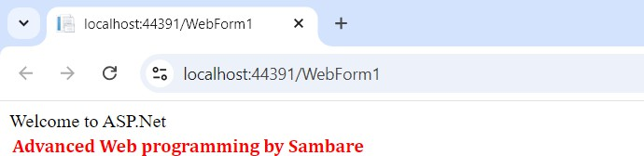

**----------------------------------------------------------------------------------------------------------------------------------------------**

## Practical 5(A)

**Aim.**

**Create web forms to demonstrate use of Website Navigation contriols and Site Map**

Add Site Map file

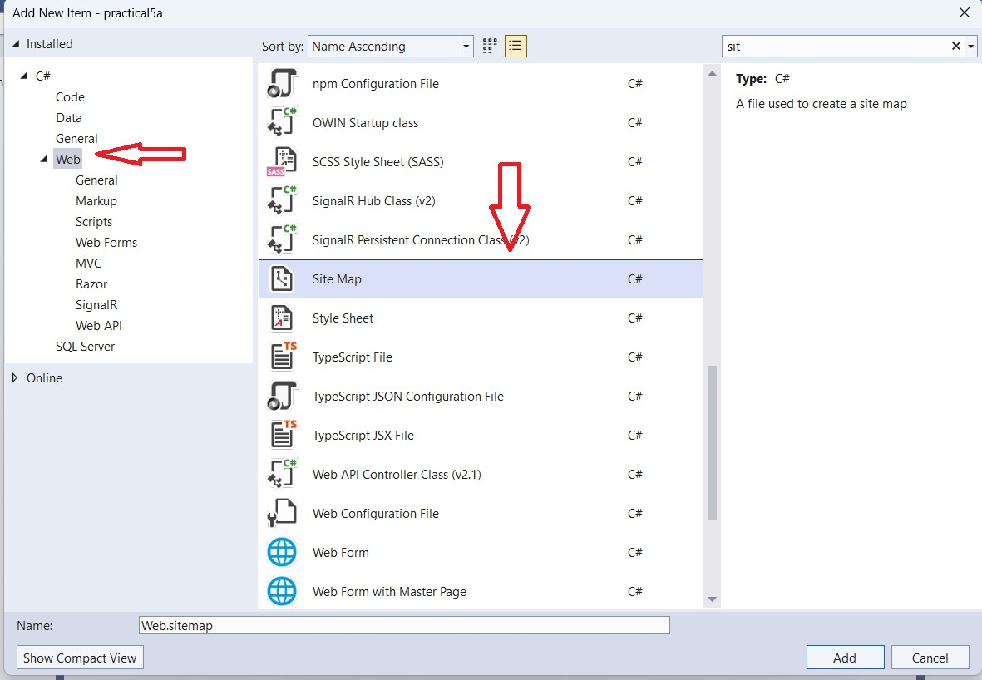

**Step 1:**

**Web.Sitemap**

<?xml version="1.0" encoding="utf-8" ?>

<siteMap xmln[s="h](http://schemas.microsoft.com/AspNet/SiteMap-File-1.0)ttp[://schemas.microsoft.com/AspNet/SiteMap-File-1.0](http://schemas.microsoft.com/AspNet/SiteMap-File-1.0)" >

<siteMapNode url="pract5a.aspx" title="Home" description="Home page of our web

site">

</siteMap>

<siteMapNode url="clsProp.aspx" title="Page2" description="Page2" />

<siteMapNode url="Default3.aspx" title="Page3" description="Page3" />

<siteMapNode url="Default2.aspx" title="Page4" description="Page4" />

</siteMapNode>

**Add SiteMapDataSource control and Menu control from toolbox to the page**

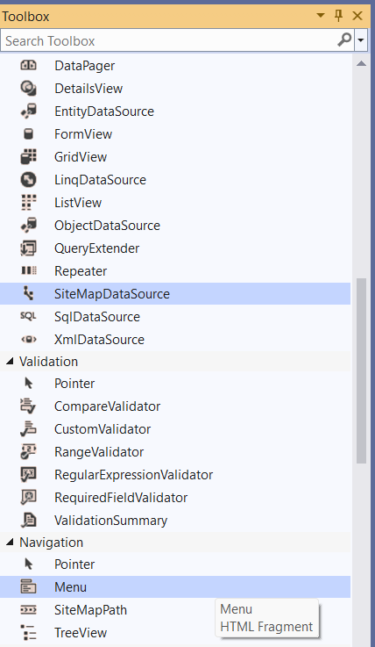

**Pract5a.aspx:**

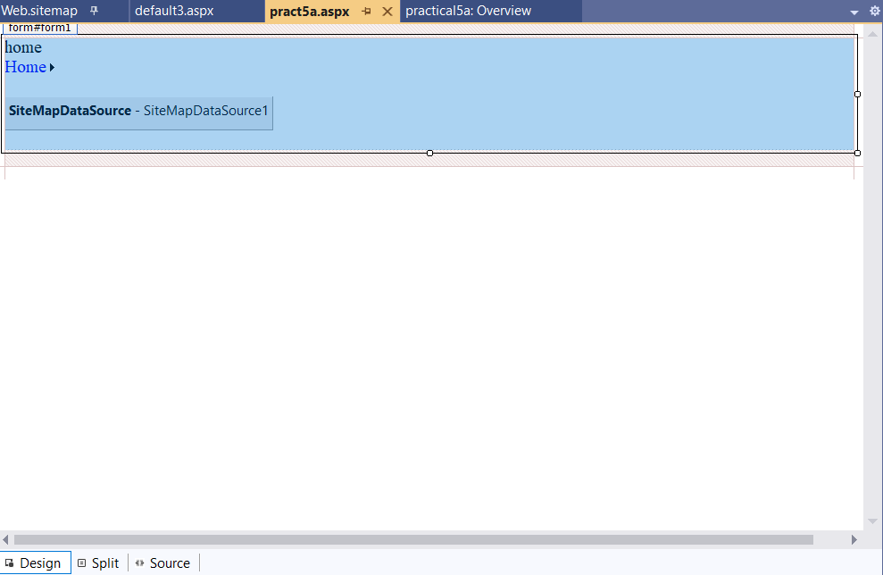

<%@ Page Language="C#" AutoEventWireup="true" CodeBehind="pract5a.aspx.cs" Inherits="practical5a.WebForm1" %>

<!DOCTYPE html>

<html xmln[s="h](http://www.w3.org/1999/xhtml)ttp[://www.w3.org/1999/xhtml">](http://www.w3.org/1999/xhtml)

<head runat="server">

<title></title>

</head>

<body>

<form id="form1" runat="server">

<div>

<asp:Label ID="Label1" runat="server" Text="home"></asp:Label>

<br />

<asp:Menu ID="Menu1" runat="server" DataSourceID="SiteMapDataSource1">

</asp:Menu>

<br />

<asp:SiteMapDataSource ID="SiteMapDataSource1" runat="server" />

<br />

</div>

</form>

</body>

</html>

**Step4:**

**Default3.aspx:**

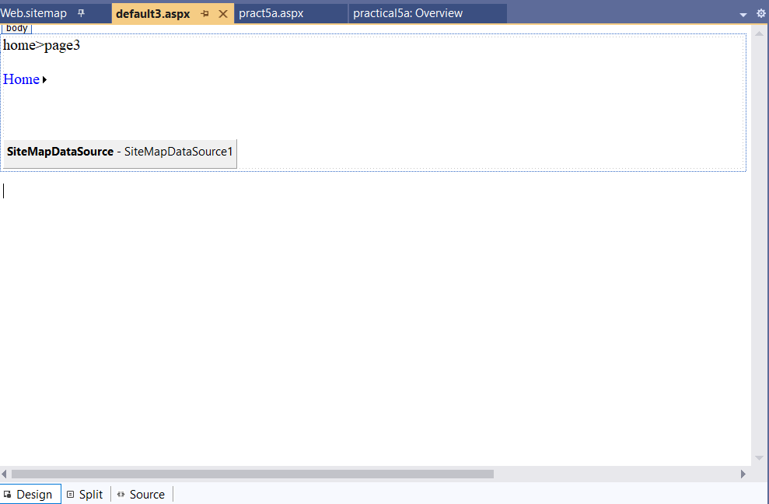

<%@ Page Language="C#" AutoEventWireup="true" CodeBehind="default3.aspx.cs" Inherits="practical5a.default3" %>

<!DOCTYPE html>

<html xmln[s="h](http://www.w3.org/1999/xhtml)ttp[://www.w3.org/1999/xhtml">](http://www.w3.org/1999/xhtml)

<head runat="server">

<title></title>

</head>

<body>

<form id="form1" runat="server">

<div>

<asp:Label ID="Label1" runat="server" Text="home&gt;page3"></asp:Label>

<br />

<br />

<asp:Menu ID="Menu1" runat="server" DataSourceID="SiteMapDataSource1">

</asp:Menu>

<br />

<br />

<asp:SiteMapDataSource ID="SiteMapDataSource1" runat="server" />

</div>

</form>

</body>

</html>

**Output:**

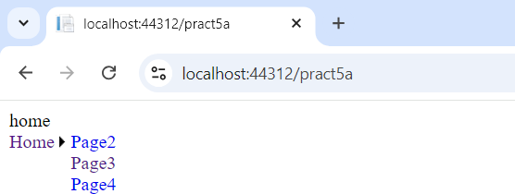

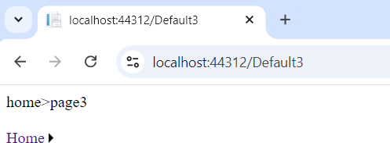

**----------------------------------------------------------------------------------------------------------------------------------------------**

## Practical 5(B)

**Aim:**

**Create a web application to demonstrate use of Master Page and content page MasterPage.master:**

<%@ Master Language="C#" AutoEventWireup="true" CodeBehind="MasterPage.master.cs" Inherits="practical5b.MasterPage" %>

<!DOCTYPE html>

<html>

<head runat="server">

<title></title>

<asp:ContentPlaceHolder ID="head" runat="server">

</asp:ContentPlaceHolder>

</head>

<body>

<form id="form1" runat="server">

<div>

<asp:ContentPlaceHolder ID="ContentPlaceHolder1" runat="server">

</asp:ContentPlaceHolder>

<asp:ContentPlaceHolder ID="ContentPlaceHolder2" runat="server">

</asp:ContentPlaceHolder>

</div>

</form>

</body>

</html>

**Demo.aspx:**

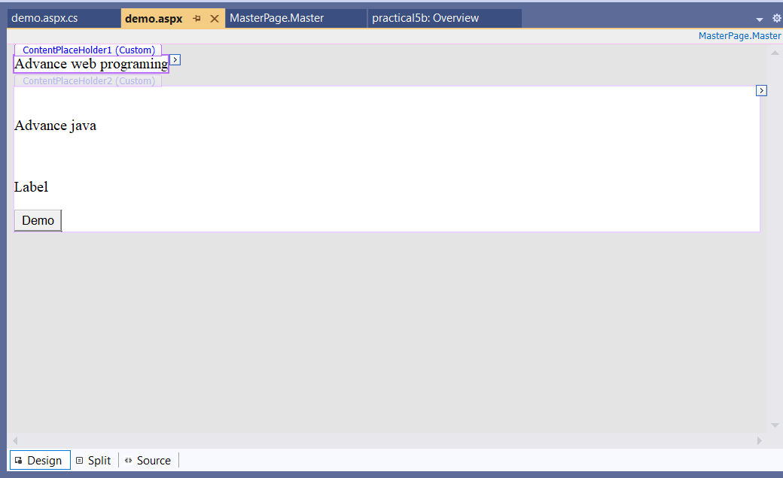

<%@ Page Language="C#" MasterPageFile="~/MasterPage.Master" AutoEventWireup="true" CodeBehind="demo.aspx.cs" Inherits="practical5b.WebForm1" %>

<asp:Content ID="Content1" ContentPlaceHolderID="Head" runat="server">

</asp:Content>

<asp:Content ID="Content2" ContentPlaceHolderID="ContentPlaceHolder1" runat="server">

<asp:Label ID="Label1" runat="server" Text="Advance web programing"></asp:Label>

</asp:Content>

<asp:Content ID="Content3" ContentPlaceHolderID="ContentPlaceHolder2" runat="server">

<p>

<br />

</p>

<p>

<asp:Label ID="Label2" runat="server" Text="Advance java"></asp:Label>

</p>

<p>

&nbsp;</p>

<p>

<asp:Label ID="Label3" runat="server" Text="Label"></asp:Label>

</p>

<p>

<asp:Button ID="Button1" runat="server" OnClientClick="Button1_Click" Text="Demo" />

</p>

</asp:Content>

**Output:**

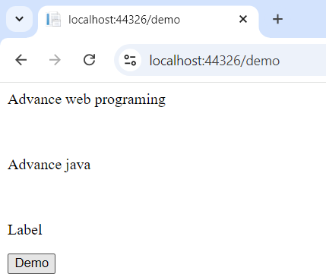

**----------------------------------------------------------------------------------------------------------------------------------------------**

## Practical 5(C)

**Aim:**

**Create a web application to demonstraten various stages of ASP.NET Pages.**

1. 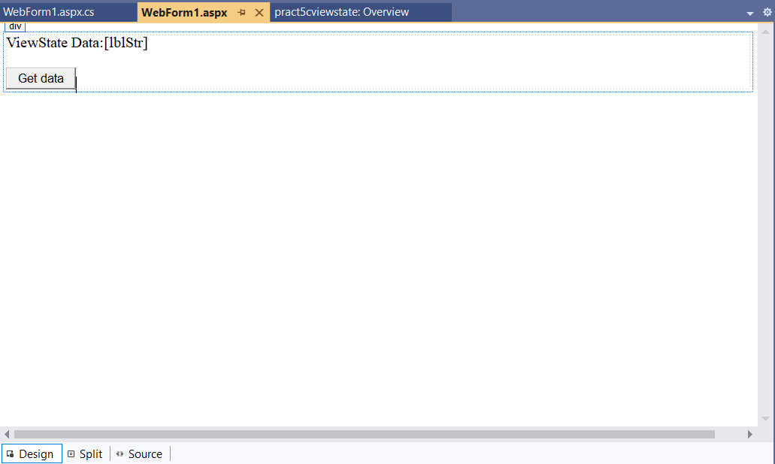**View state:**

**Pract5c.aspx:**

<%@ Page Language="C#" AutoEventWireup="true" CodeBehind="WebForm1.aspx.cs" Inherits="pract5cviewstate.WebForm1" %>

<!DOCTYPE html>

<html xmln[s="h](http://www.w3.org/1999/xhtml)ttp[://www.w3.org/1999/xhtml">](http://www.w3.org/1999/xhtml)

<head runat="server">

<title></title>

</head>

<body>

<form id="form1" runat="server">

<div>

<asp:Label ID="lavel1" runat="server" Text="ViewState Data:"></asp:Label>

<asp:Label ID="lblStr" runat="server"></asp:Label>

<br />

<br />

<asp:Button ID="Button1" runat="server" OnClick="Button1_Click" Text="Get data" />

</div>

</form>

</body>

</html>

**Pract5c.aspx.cs:**

using System;

using System.Collections.Generic; using System.Linq;

using System.Web; using System.Web.UI;

using System.Web.UI.WebControls;

namespace pract5cviewstate

{

public partial class WebForm1 : System.Web.UI.Page

{

protected void Page_Load(object sender, EventArgs e)

{

if (!IsPostBack)

{

string str = "Ajay Pashankar"; if (ViewState["nam"] == null)

{

ViewState["nam"] = str;

}

}

}

protected void Button1_Click(object sender, EventArgs e)

{

lblStr.Text = ViewState["nam"].ToString();

}

}

}

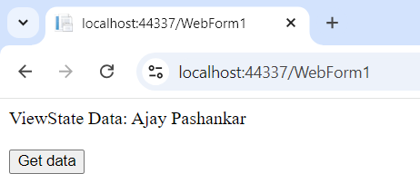**Output:**

**------------------------------------------------------------------------------------------------------------------------------**

1. **QueryString:**

**Default3.aspx:**

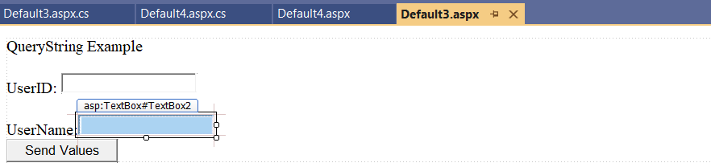

**Code:**

<%@ Page Language="C#" AutoEventWireup="true" CodeBehind="Default3.aspx.cs" Inherits="querystate.WebForm1" %>

<!DOCTYPE html>

<html xmln[s="h](http://www.w3.org/1999/xhtml)ttp[://www.w3.org/1999/xhtml">](http://www.w3.org/1999/xhtml)

<head runat="server">

<title></title>

</head>

<body>

<form id="form1" runat="server">

<div>

<asp:Label ID="Label1" runat="server" Text="QueryString Example"></asp:Label>

<br />

<br />

<asp:Label ID="txtUserId" runat="server" Text="UserID:"></asp:Label> &nbsp;<asp:TextBox ID="TextBox1" runat="server"></asp:TextBox>

<br />

<br />

<asp:Label ID="txtUserName" runat="server" Text="UserName:"></asp:Label>

<asp:TextBox ID="TextBox2" runat="server"></asp:TextBox>

<br />

<asp:Button ID="Button1" runat="server" OnClick="Button1_Click" Text="Send Values" />

</div>

</form>

</body>

</html>

**Default3.aspx.cs:**

using System;

using System.Collections.Generic; using System.Linq;

using System.Web; using System.Web.UI;

using System.Web.UI.WebControls;

namespace querystate

{

public partial class WebForm1 : System.Web.UI.Page

{

protected void Page_Load(object sender, EventArgs e)

{

}

protected void Button1_Click(object sender, EventArgs e)

{

Response.Redirect("Default4.aspx?txtUserId=" + Server.UrlEncode(TextBox1.Text) + "&txtUserName=" + Server.UrlEncode(TextBox2.Text));

}

}}

**Default4.aspx:**

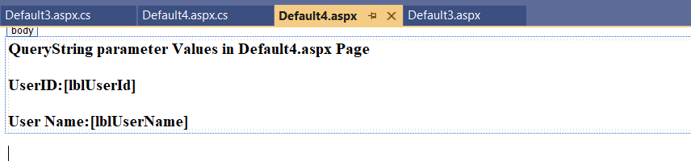

**Code:**

<%@ Page Language="C#" AutoEventWireup="true" CodeBehind="Default4.aspx.cs" Inherits="querystate.Default4" %>

<!DOCTYPE html>

<html xmln[s="h](http://www.w3.org/1999/xhtml)ttp[://www.w3.org/1999/xhtml">](http://www.w3.org/1999/xhtml)

<head runat="server">

<title></title>

</head>

<body>

<form id="form1" runat="server">

<div>

<asp:Label ID="Label1" runat="server" Font-Bold="True" Text="QueryString parameter Values in Default4.aspx Page"></asp:Label>

<br />

<br />

<asp:Label ID="Label2" runat="server" Font-Bold="True" Text="UserID:"></asp:Label>

<asp:Label ID="lblUserId" runat="server" Font-Bold="True"></asp:Label>

<br />

<br />

<asp:Label ID="Label3" runat="server" Font-Bold="True" Text="User Name:"></asp:Label>

<asp:Label ID="lblUserName" runat="server" Font-Bold="True"></asp:Label>

</div>

</form>

</body>

</html>

**Default.aspx.cs:**

using System;

using System.Collections.Generic; using System.Linq;

using System.Web; using System.Web.UI;

using System.Web.UI.WebControls;

namespace querystate

{

public partial class Default4 : System.Web.UI.Page

{

protected void Page_Load(object sender, EventArgs e)

{

if (!IsPostBack)

{

lblUserId.Text = Request.QueryString["txtUserId"];

lblUserName.Text = Request.QueryString["txtUserName"];

}

}

}

}

**Output:**

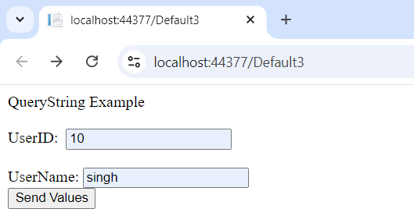

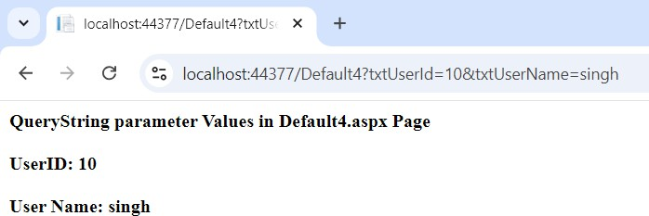

**----------------------------------------------------------------------------------------------------------------------------------------------**

1. **Cookies:**

**Defult5.aspx:**

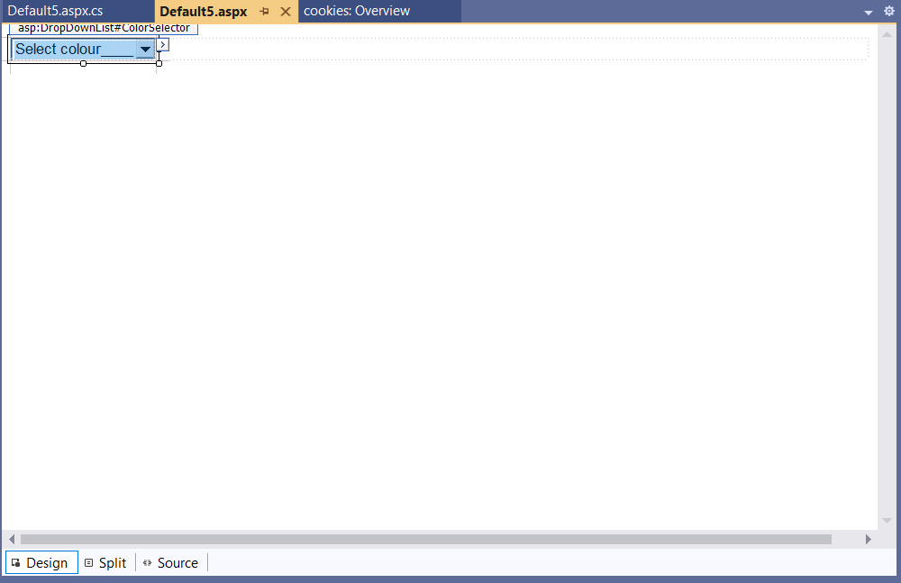

<%@ Page Language="C#" AutoEventWireup="true" CodeBehind="Default5.aspx.cs" Inherits="cookies.WebForm1" %>

<!DOCTYPE html>

<html xmln[s="h](http://www.w3.org/1999/xhtml)ttp[://www.w3.org/1999/xhtml">](http://www.w3.org/1999/xhtml)

<head runat="server">

<title></title>

</head>

<body id="BodyTag" runat="server">

<form id="form1" runat="server">

<div>

<asp:DropDownList ID="ColorSelector" runat="server" AutoPostBack="True" OnSelectedIndexChanged="ColorSelector_IndexChanged">

<asp:ListItem Value="white" Selected="True">Select colour </asp:ListItem>

<asp:ListItem Value="red">red</asp:ListItem>

<asp:ListItem Value="green">green</asp:ListItem>

<asp:ListItem Value="blue">blue</asp:ListItem>

</asp:DropDownList>

</div>

</form>

</body>

</html>

**Defult5.aspx.cs:**

using System;

using System.Collections.Generic; using System.Drawing;

using System.Linq; using System.Web; using System.Web.UI;

using System.Web.UI.WebControls;

namespace cookies

{

public partial class WebForm1 : System.Web.UI.Page

{

protected void Page_Load(object sender, EventArgs e)

{

if (Request.Cookies["BackgroundColor"] != null)

ColorSelector.SelectedValue = Request.Cookies["BackgroundColor"].Value; BodyTag.Style["background-color"] = ColorSelector.SelectedValue;

}

protected void ColorSelector_IndexChanged(object sender, EventArgs e)

{

BodyTag.Style["background-color"] = ColorSelector.SelectedValue; HttpCookie cookie = new HttpCookie("BackgroundColor"); cookie.Value = ColorSelector.SelectedValue;

cookie.Expires=DateTime.Now.AddMilliseconds(20); Response.SetCookie(cookie);

}

}

}

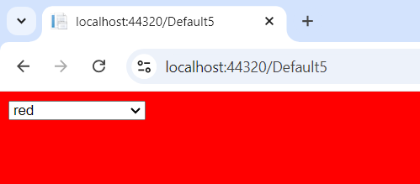**Output:**

-

1. **Session and application state:**

**Global.asax:**

<%@ Application CodeBehind="Global.asax.cs" Inherits="sessionandapplicationstate.Global" Language="C#" %>

<script runat="server">

void Application_Start(object sender, EventArgs e)

{

Application["Online Users"] = 0; // Initialize application variable

}

void Application_End(object sender, EventArgs e)

{

}

void Application_Error(object sender, EventArgs e)

{

}

void Session_Start(object sender, EventArgs e)

{

null

}

Application.Lock();

Application["Online Users"] = (int)(Application["Online Users"] ?? 0) + 1; // Safely handle Application.UnLock();

void Session_End(object sender, EventArgs e)

{

null

}

Application.Lock();

Application["Online Users"] = (int)(Application["Online Users"] ?? 0) - 1; // Safely handle Application.UnLock();

</script>

**Web.config:**

<?xml version="1.0" encoding="utf-8"?>

<configuration>

<system.web>

<sessionState mode="InProc" cookieless="false" timeout="1"/>

<compilation debug="true" targetFramework="4.5.2"/>

<httpRuntime targetFramework="4.5.2"/>

</system.web>

**Default.aspx:**

<%@ Page Language="C#" AutoEventWireup="true" CodeBehind="WebForm1.aspx.cs" Inherits="sessionandapplicationstate.WebForm1" %>

<!DOCTYPE html>

<html xmln[s="h](http://www.w3.org/1999/xhtml)ttp[://www.w3.org/1999/xhtml">](http://www.w3.org/1999/xhtml)

<head runat="server">

<title></title>

</head>

<body>

<form id="form1" runat="server">

<div>

Visitors Count :<%=Application["Online Users"].ToString() %>

</div>

</form>

</body>

</html>

**Output:**

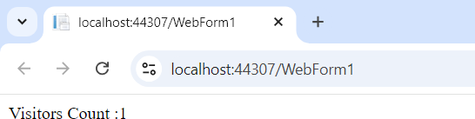

**-------------------------------------------------------------------------------------------------------------------------------**

**Database prerequisite:**

**Here we add new database in our website as shown below .add this database inside App_Data folder. Step1:**

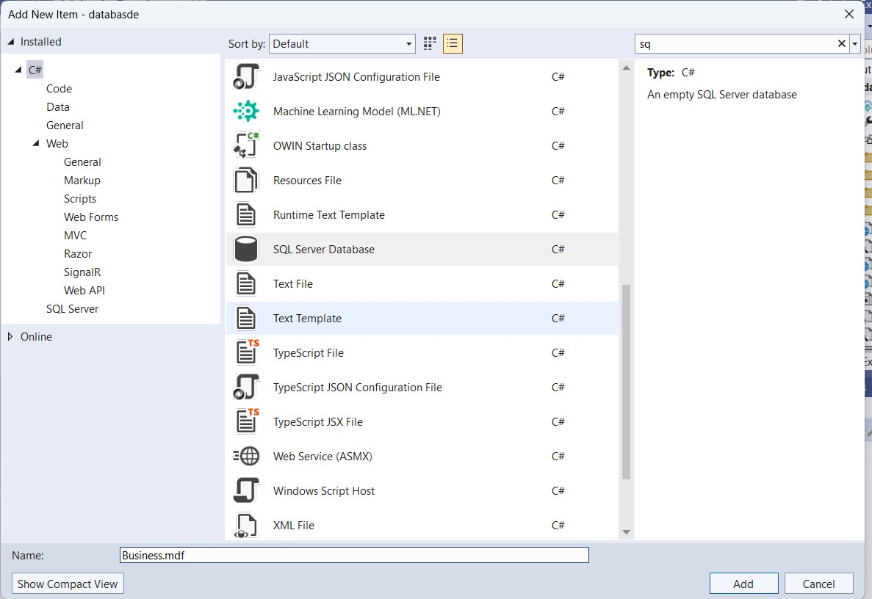

**Step2:**

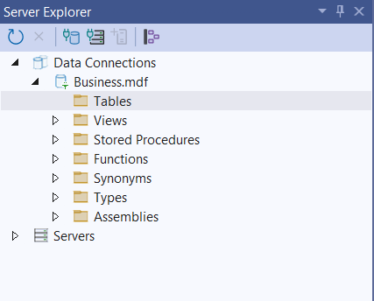

**Step3:**

**The structure of the table are displayed below Customer table:**

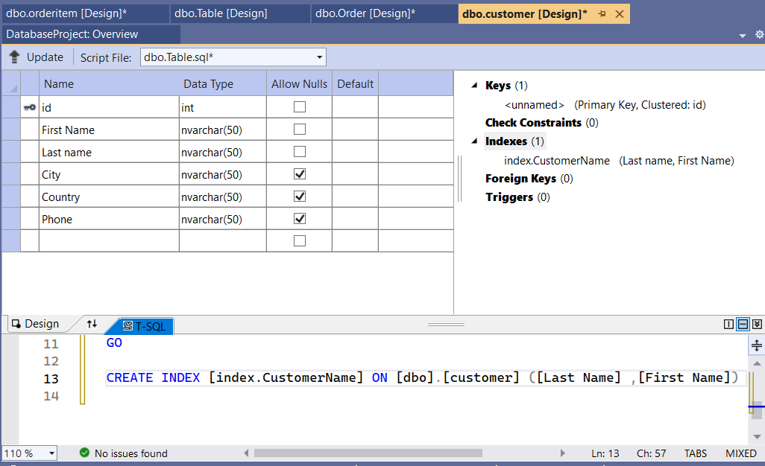

**Order table:**

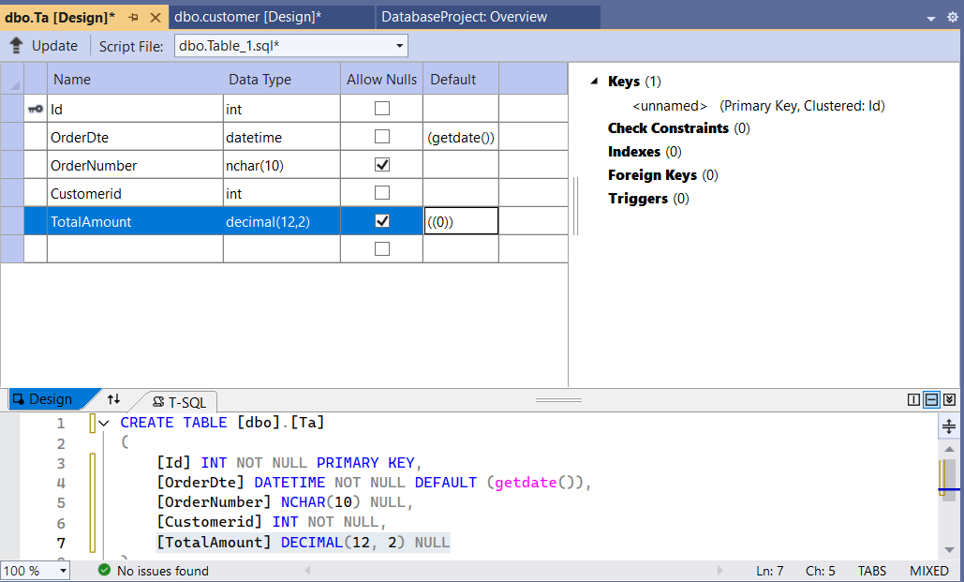

**OrderItem Table:**

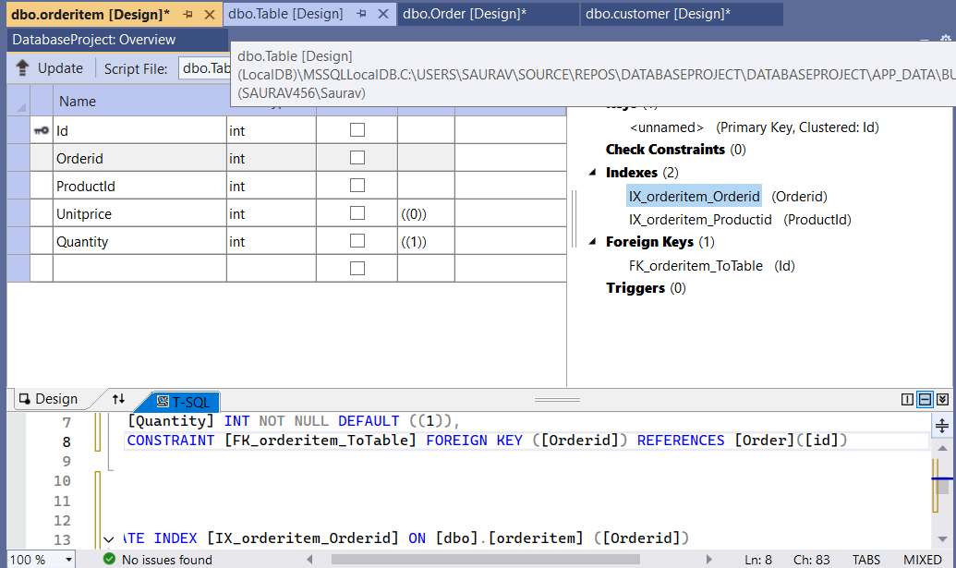

**Product Table:**

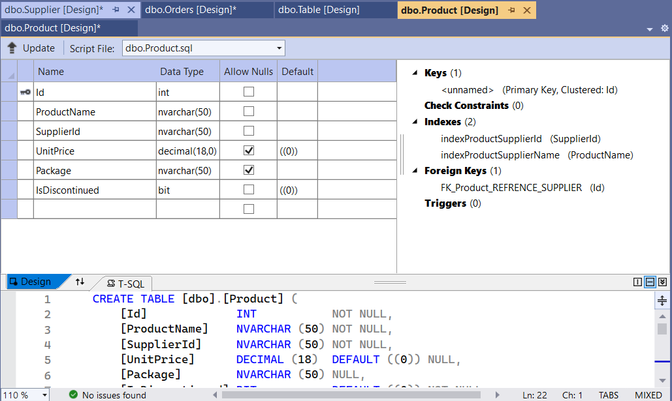

**Supplier Table:**

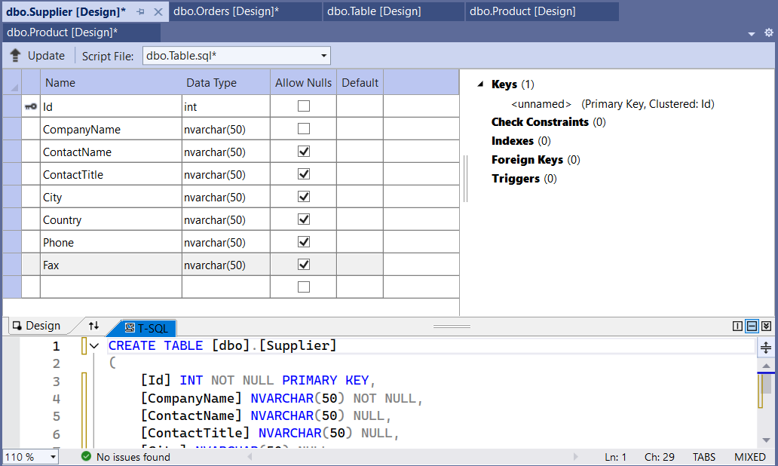

**----------------------------------------------------------------------------------------------------------------------------------------------**

# PRACTICAL 6(A)

**Aim:**

**Create a web application for inserting and deleting records from database.**

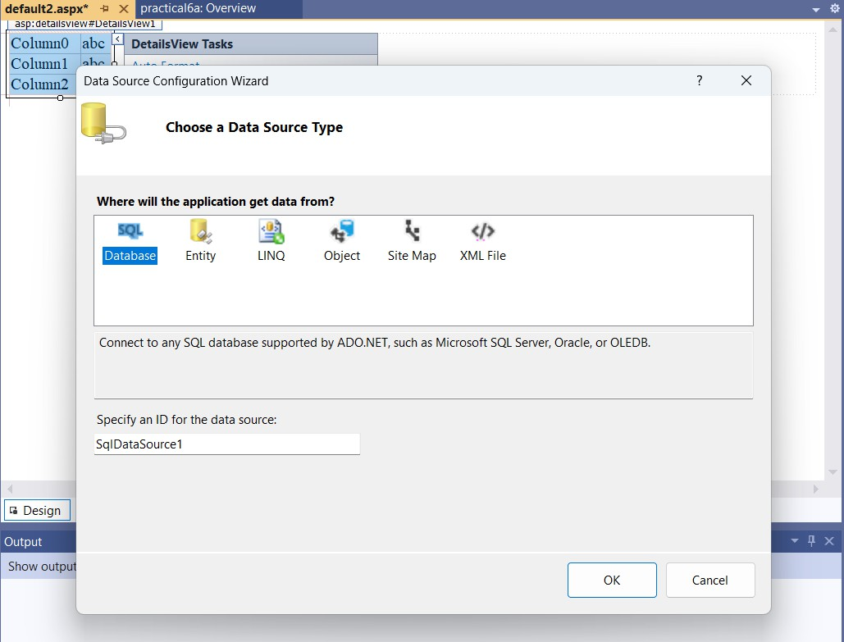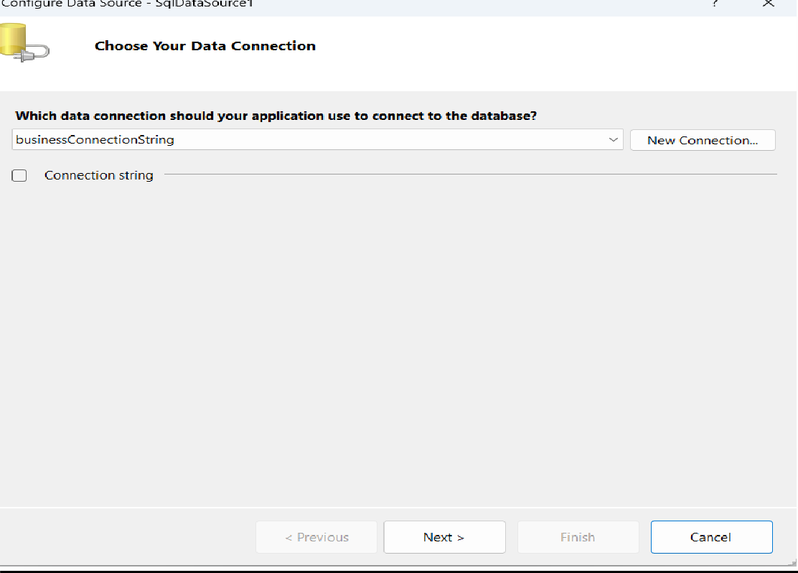

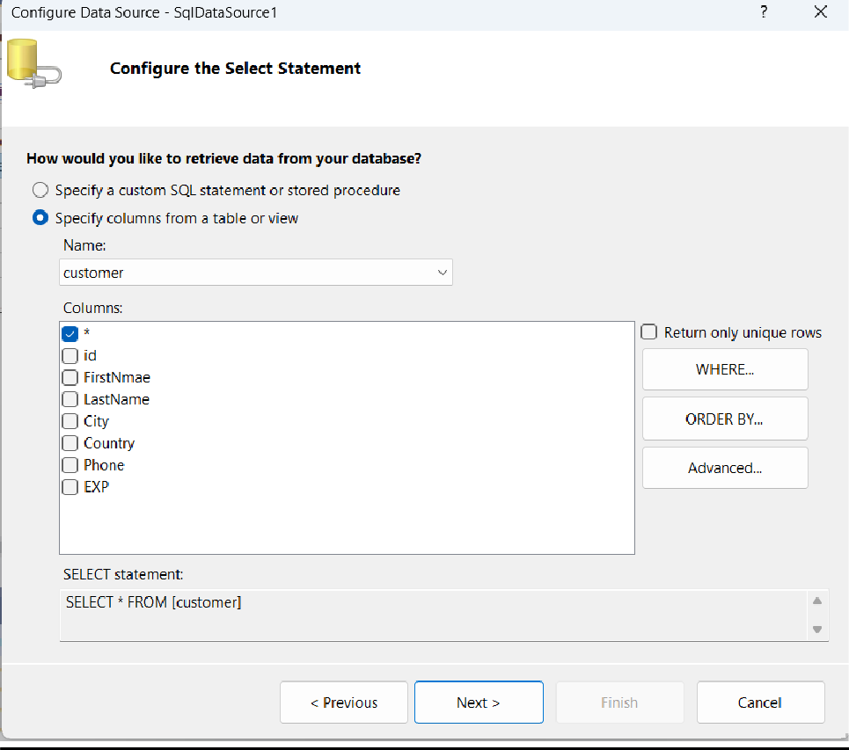

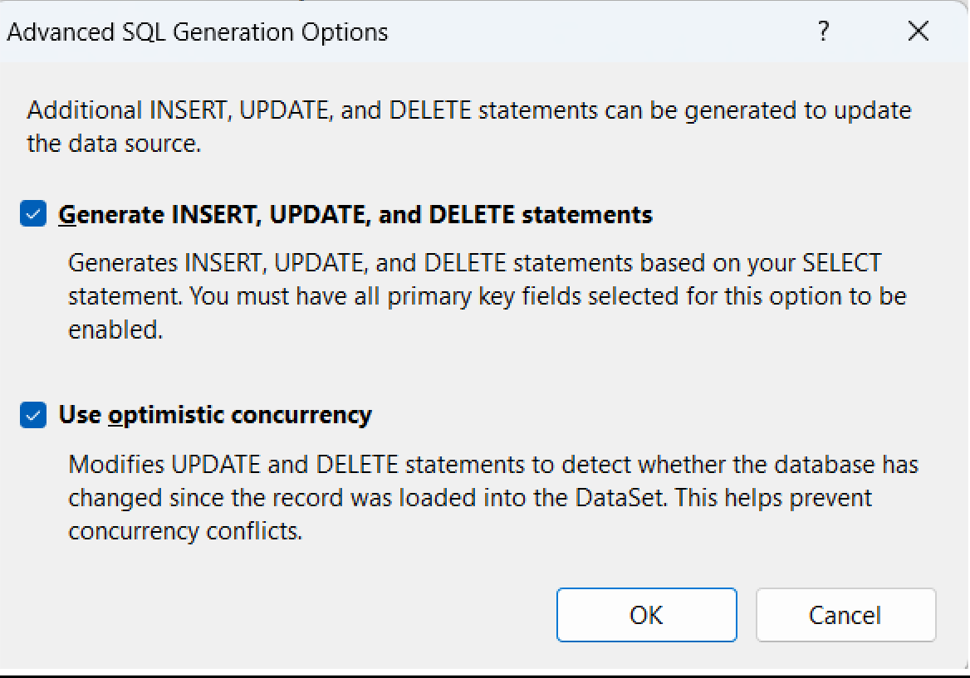

**Default2.aspx:**

<%@ Page Language="C#" AutoEventWireup="true" CodeBehind="WebForm1.aspx.cs" Inherits="practical6a.WebForm1" %>

<!DOCTYPE html>

<html xmln[s="h](http://www.w3.org/1999/xhtml)ttp[://www.w3.org/1999/xhtml">](http://www.w3.org/1999/xhtml)

<head runat="server">

<title></title>

</head>

<body>

<form id="form1" runat="server">

<div>

<asp:SqlDataSource ID="SqlDataSource1" runat="server" ConflictDetection="CompareAllValues"

ConnectionString="<%$ ConnectionStrings:businessConnectionString %>" DeleteCommand="DELETE FROM [customer] WHERE [id] = @original_id AND [FirstNmae] = @original_FirstNmae AND [LastName] =

@original_LastName AND (([City] = @original_City) OR ([City] IS NULL AND @original_City IS NULL)) AND (([Country] = @original_Country) OR ([Country] IS NULL AND @original_Country IS NULL)) AND (([Phone] = @original_Phone) OR ([Phone] IS NULL AND @original_Phone IS NULL)) AND (([EXP] = @original_EXP) OR ([EXP] IS NULL AND @original_EXP IS NULL))" InsertCommand="INSERT INTO [customer] ([id], [FirstNmae], [LastName], [City], [Country], [Phone], [EXP]) VALUES (@id, @FirstNmae, @LastName, @City, @Country, @Phone, @EXP)" OldValuesParameterFormatString="original_{0}"

OnSelecting="SqlDataSource1_Selecting" SelectCommand="SELECT * FROM [customer]"

UpdateCommand="UPDATE [customer] SET [FirstNmae] = @FirstNmae, [LastName] = @LastName, [City] = @City, [Country] = @Country, [Phone] = @Phone, [EXP] = @EXP WHERE [id] = @original_id AND

[FirstNmae] = @original_FirstNmae AND [LastName] = @original_LastName AND (([City] = @original_City) OR ([City] IS NULL AND @original_City IS NULL)) AND (([Country] = @original_Country) OR ([Country] IS NULL AND @original_Country IS NULL)) AND (([Phone] = @original_Phone) OR ([Phone] IS NULL AND

@original_Phone IS NULL)) AND (([EXP] = @original_EXP) OR ([EXP] IS NULL AND @original_EXP IS NULL))">

<DeleteParameters>

<asp:Parameter Name="original_id" Type="Int32" />

<asp:Parameter Name="original_FirstNmae" Type="String" />

<asp:Parameter Name="original_LastName" Type="String" />

<asp:Parameter Name="original_City" Type="String" />

<asp:Parameter Name="original_Country" Type="String" />

<asp:Parameter Name="original_Phone" Type="String" />

<asp:Parameter Name="original_EXP" Type="String" />

</DeleteParameters>

<InsertParameters>

<asp:Parameter Name="id" Type="Int32" />

<asp:Parameter Name="FirstNmae" Type="String" />

<asp:Parameter Name="LastName" Type="String" />

<asp:Parameter Name="City" Type="String" />

<asp:Parameter Name="Country" Type="String" />

<asp:Parameter Name="Phone" Type="String" />

<asp:Parameter Name="EXP" Type="String" />

</InsertParameters>

<UpdateParameters>

<asp:Parameter Name="FirstNmae" Type="String" />

<asp:Parameter Name="LastName" Type="String" />

<asp:Parameter Name="City" Type="String" />

<asp:Parameter Name="Country" Type="String" />

<asp:Parameter Name="Phone" Type="String" />

<asp:Parameter Name="EXP" Type="String" />

<asp:Parameter Name="original_id" Type="Int32" />

<asp:Parameter Name="original_FirstNmae" Type="String" />

<asp:Parameter Name="original_LastName" Type="String" />

<asp:Parameter Name="original_City" Type="String" />

<asp:Parameter Name="original_Country" Type="String" />

<asp:Parameter Name="original_Phone" Type="String" />

<asp:Parameter Name="original_EXP" Type="String" />

</UpdateParameters>

</asp:SqlDataSource>

<br />

<asp:DetailsView ID="DetailsView1" runat="server" AutoGenerateRows="False" DataKeyNames="id" DataSourceID="SqlDataSource1" Height="50px"

OnPageIndexChanging="DetailsView1_PageIndexChanging" Width="125px">

<Fields>

<asp:BoundField DataField="id" HeaderText="id" ReadOnly="True" SortExpression="id" />

<asp:BoundField DataField="FirstNmae" HeaderText="FirstNmae" SortExpression="FirstNmae" />

<asp:BoundField DataField="LastName" HeaderText="LastName" SortExpression="LastName" />

<asp:BoundField DataField="City" HeaderText="City" SortExpression="City" />

<asp:BoundField DataField="Country" HeaderText="Country" SortExpression="Country" />

<asp:BoundField DataField="Phone" HeaderText="Phone" SortExpression="Phone" />

<asp:BoundField DataField="EXP" HeaderText="EXP" SortExpression="EXP" />

<asp:CommandField ShowDeleteButton="True" ShowInsertButton="True" />

</Fields>

</asp:DetailsView>

<br />

<br />

</div>

</form>

</body>

</html>

**Output:**

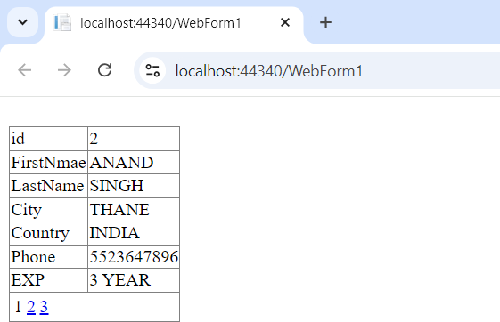

**---------------------------------------------------------------------------------------------------------------------------------------------**

# PRACTICAL 6(B)

**Aim:**

**Create a web application to display using Disconnected Data Access and Databinding using Gridview**

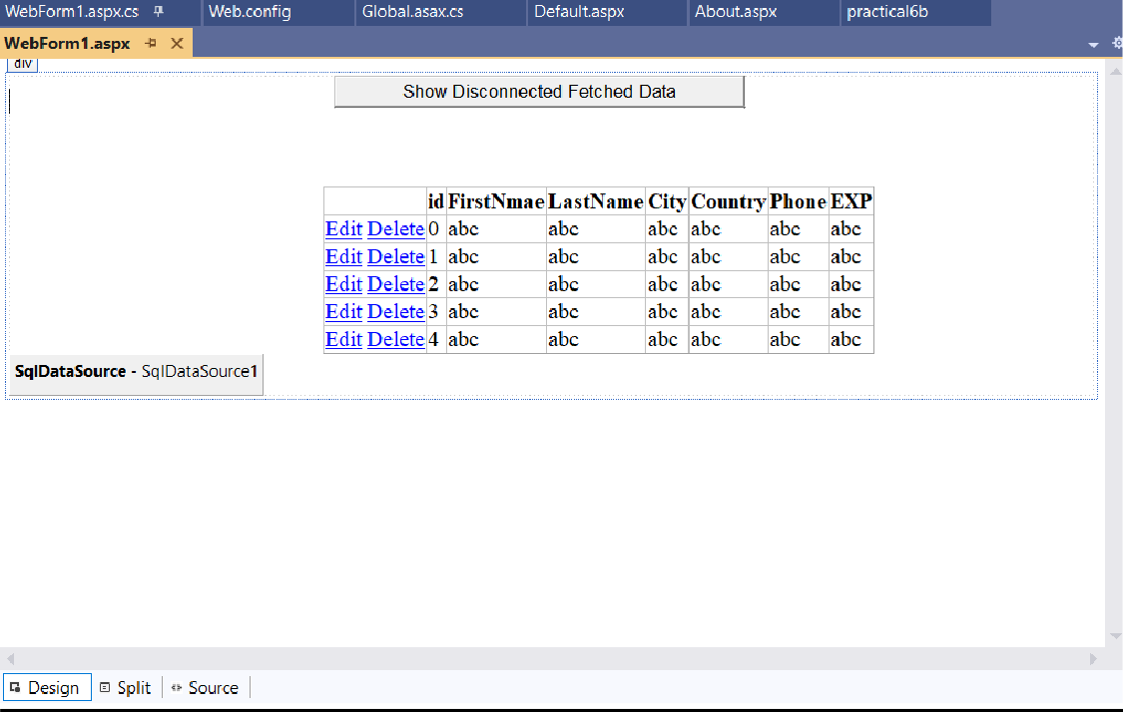

**Default.aspx:**

<%@ Page Language="C#" AutoEventWireup="true" CodeBehind="WebForm1.aspx.cs" Inherits="practical6b.WebForm1" %>

<!DOCTYPE html>

<html xmln[s="h](http://www.w3.org/1999/xhtml)ttp[://www.w3.org/1999/xhtml">](http://www.w3.org/1999/xhtml)

<head runat="server">

<title></title>

<style type="text/css">

.auto-style1 {

margin-left: 285px;

}

</style>

</head>

<body>

<form id="form1" runat="server">

<div>

<asp:Button ID="Button1" runat="server" OnClick="Button1_Click" OnClientClick="button1_click" Text="Show Disconnected Fetched Data" />

<br />

<br />

<br /> &nbsp;&nbsp;

<asp:GridView ID="GridView1" runat="server" CssClass="auto-style1" DataSourceID="SqlDataSource1" Width="252px" AutoGenerateColumns="False" DataKeyNames="id">

<Columns>

<asp:CommandField ShowDeleteButton="True" ShowEditButton="True" />

<asp:BoundField DataField="id" HeaderText="id" ReadOnly="True" SortExpression="id" />

<asp:BoundField DataField="FirstNmae" HeaderText="FirstNmae" SortExpression="FirstNmae" />

<asp:BoundField DataField="LastName" HeaderText="LastName" SortExpression="LastName" />

<asp:BoundField DataField="City" HeaderText="City" SortExpression="City" />

<asp:BoundField DataField="Country" HeaderText="Country" SortExpression="Country" />

<asp:BoundField DataField="Phone" HeaderText="Phone" SortExpression="Phone" />

<asp:BoundField DataField="EXP" HeaderText="EXP" SortExpression="EXP" />

</Columns>

</asp:GridView>

<asp:SqlDataSource ID="SqlDataSource1" runat="server" ConnectionString="<%$

ConnectionStrings:businessConnectionString %>" OldValuesParameterFormatString="original_{0}" SelectCommand="SELECT * FROM [customer]"></asp:SqlDataSource>

</div>

</form>

</body>

</html>

**Default.aspx.cs:**

using System;

using System.Collections.Generic; using System.Linq;

using System.Web; using System.Web.UI;

using System.Web.UI.WebControls;

using System.Configuration; using System.Data.SqlClient; using System.Data;

namespace practical6b

{

public partial class WebForm1 : System.Web.UI.Page

{

protected void Page_Load(object sender, EventArgs e)

{

}

protected void Button1_Click(object sender, EventArgs e)

{

string connStr = ConfigurationManager.ConnectionStrings["connStr"].ConnectionString;

SqlConnection con =new SqlConnection(connStr);

SqlDataAdapter objDa= new SqlDataAdapter();

DataSet objDs= new DataSet();

using (SqlConnection objConn = new SqlConnection(connStr))

{

SqlCommand objCmd = new SqlCommand("Select * from Customer",objConn);

objCmd.CommandType =CommandType.Text;

objDa.SelectCommand =objCmd;

objDa.Fill(objDs, "Product");

GridView1.DataSource = objDs.Tables[0]; GridView1.DataBind();

}

}

}

}

**Output:**

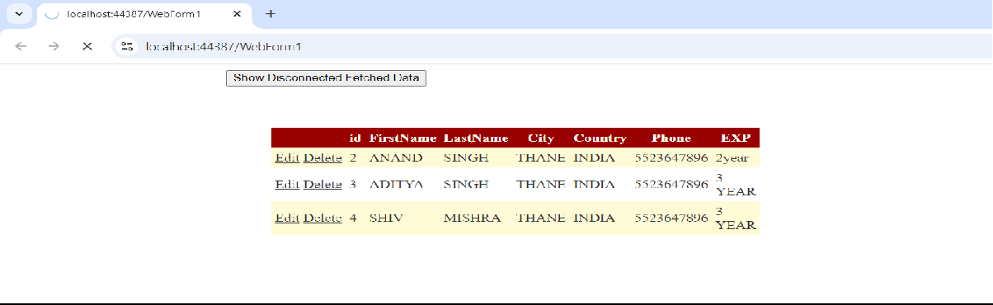

**----------------------------------------------------------------------------------------------------------------------------------------------**

## Practical 7(A)

**Aim:**

**Create a web application to demonstrate the use of different types of cookies.**

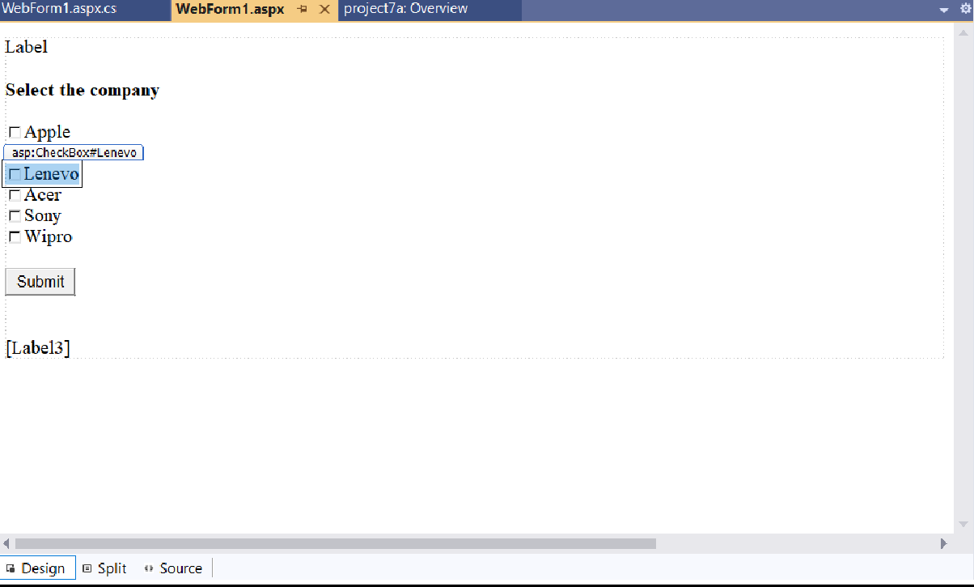

**Cookie.aspx:**

<%@ Page Language="C#" AutoEventWireup="true" CodeBehind="WebForm1.aspx.cs" Inherits="project7a.WebForm1" %>

<!DOCTYPE html>

<html xmln[s="h](http://www.w3.org/1999/xhtml)ttp[://www.w3.org/1999/xhtml">](http://www.w3.org/1999/xhtml)

<head runat="server">

<title></title>

</head>

<body>

<form id="form1" runat="server">

<div>

<asp:Label ID="Label2" runat="server" Text="Label"></asp:Label>

<br />

<br />

<asp:Label ID="Label1" runat="server" Font-Bold="True" Text="Select the company"></asp:Label>

<br />

<br />

<asp:CheckBox ID="Apple" runat="server" Text="Apple" />

<br />

<asp:CheckBox ID="Dell" runat="server" Text="Dell" />

<br />

<asp:CheckBox ID="Lenevo" runat="server" Text="Lenevo" />

<br />

<asp:CheckBox ID="Acer" runat="server" Text="Acer" />

<br />

<asp:CheckBox ID="Sony" runat="server" Text="Sony" />

<br />

<asp:CheckBox ID="Wipro" runat="server" Text="Wipro" />

<br />

<br />

<asp:Button ID="Button1" runat="server" OnClick="Button1_Click" Text="Submit" />

<br />

<br />

<br />

<asp:Label ID="Label3" runat="server"></asp:Label>

</div>

</form>

<p>

<br />

</p>

</body>

</html>

**Cookie.aspx.cs:**

using System;

using System.Collections.Generic; using System.Linq;

using System.Runtime.ConstrainedExecution; using System.Web;

using System.Web.UI;

using System.Web.UI.WebControls;

namespace project7a

{

public partial class WebForm1 : System.Web.UI.Page

{

protected void Page_Load(object sender, EventArgs e)

{

// Creating HttpCookie instance by name "creator" HttpCookie c1= new HttpCookie("creator");

// Assigning value to the created cookie c1.Value = "Dr. Tushar Sambare";

// Adding Cookie to the response instance

Response.Cookies.Add(c1);

String author=Response.Cookies["creator"].Value;

Label2.Text =author;

//Second Cookie

Response.Cookies["comp"].Expires = DateTime.Now.AddDays(-1);

}

protected void Button1_Click(object sender, EventArgs e)

{

Label3.Text = "";

// Adding Coockies //

if (Apple.Checked)

Response.Cookies["comp"]["apple"] = "apple"; if (Dell.Checked)

Response.Cookies["comp"]["dell"] = "dell"; if (Lenevo.Checked)

Response.Cookies["comp"]["lenevo"] = "lenevo"; if (Acer.Checked)

Response.Cookies["comp"]["acer"] = "acer"; if (Sony.Checked)

Response.Cookies["comp"]["sony"] = "sony"; if (Wipro.Checked)

Response.Cookies["comp"]["wipro"] = "wipro";

// Fetching Cookies

if (Request.Cookies["comp"].Values.ToString() != null)

{

if (Request.Cookies["comp"]["apple"] != null)

Label3.Text += Request.Cookies["comp"] ["apple"] + ""; if (Request.Cookies["comp"]["dell"] != null)

Label3.Text += Request.Cookies["comp"] ["dell"] + ""; if (Request.Cookies["comp"] ["lenevo"] != null)

Label3.Text += Request.Cookies["comp"] ["lenevo"] + "";

if (Request.Cookies["comp"] ["acer"] != null)

Label3.Text += Request.Cookies["comp"] ["acer"] + ""; if (Request.Cookies["comp"] ["sony"] != null)

Label3.Text += Request.Cookies["comp"] ["sony"] + ""; if (Request.Cookies["comp"] ["wipro"] != null)

Label3.Text += Request.Cookies["comp"] ["wipro"] + "";

}

else Label3.Text = "Please select your choice";

Response.Cookies["comp"].Expires = DateTime.Now.AddDays(-1);

}

}

}

**Output:**

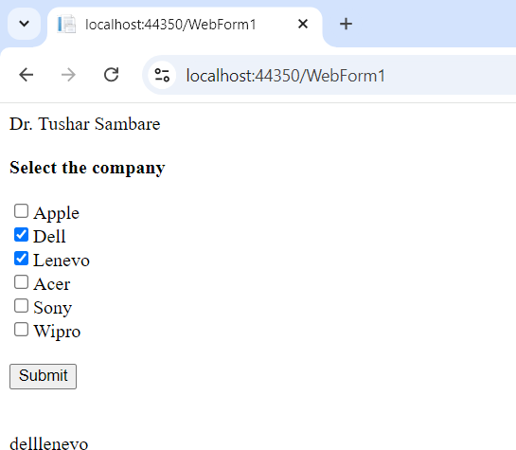

**----------------------------------------------------------------------------------------------------------------------------------------------**

## Practical 7(B)

**Aim:**

**Create a web application to demonstrate Form Security and Window Security with proper Authentication and Authorization properties.**

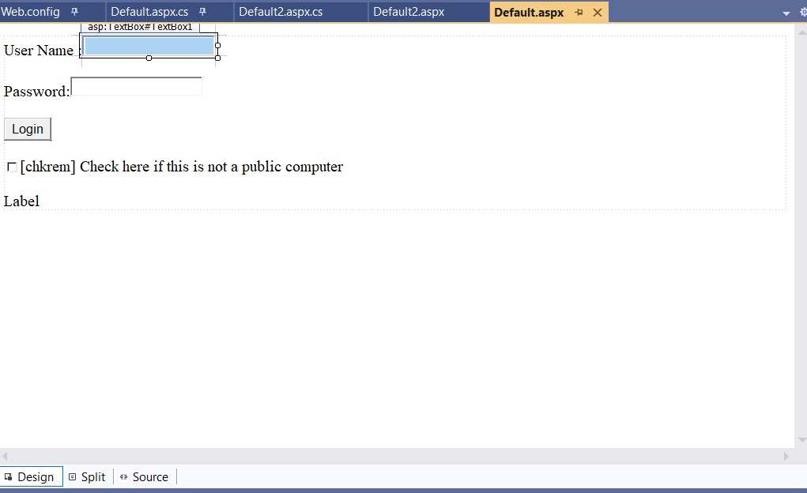

**Default.aspx:**

<%@ Page Language="C#" AutoEventWireup="true" CodeBehind="Default.aspx.cs" Inherits="practical7b.Default" %>

<!DOCTYPE html>

<html xmln[s="h](http://www.w3.org/1999/xhtml)ttp[://www.w3.org/1999/xhtml">](http://www.w3.org/1999/xhtml)

<head runat="server">

<title></title>

</head>

<body>

<form id="form1" runat="server">

<div>

<asp:Label ID="txtuser" runat="server" Text="User Name :"></asp:Label>

<asp:TextBox ID="TextBox1" runat="server"></asp:TextBox>

<br />

<br />

<asp:Label ID="txtpwd" runat="server" Text="Password:"></asp:Label>

<asp:TextBox ID="TextBox2" runat="server" TextMode="Password"></asp:TextBox>

<br />

<br />

<asp:Button ID="Button1" runat="server" OnClick="Button1_Click" Text="Login" />

<br />

<asp:CheckBox ID="chkrem" runat="server" Text="[chkrem] Check here if this is not a public computer" />

<br />

<asp:Label ID="Label3" runat="server" Text="Label"></asp:Label>

</div>

</form>

</body>

</html>

**Default.aspx.cs:**

using System;

using System.Collections.Generic; using System.Linq;

using System.Web;

using System.Web.Security; using System.Web.UI;

using System.Web.UI.WebControls;

using static System.Net.Mime.MediaTypeNames;

namespace practical7b

{

public partial class Default : System.Web.UI.Page

{

protected void Page_Load(object sender, EventArgs e)

{

}

protected bool authenticate(String uname, String pass)

{

if (uname == "Yash")

{

if (pass == "yash123")

{

return true;

}

}

if (uname == "Ved")

{

if (pass == "ved123")

{

return true;

}

}

if (uname == "Sam")

{

if (pass == "sam123")

{

return true;

}

}

return false;

}

protected void Button1_Click(object sender, EventArgs e)

{

if (authenticate(TextBox1.Text, TextBox2.Text))

{

FormsAuthentication.RedirectFromLoginPage(TextBox1.Text, chkrem.Checked); Session["Username"] =TextBox1.Text;

Response.Redirect("Default2.aspx");

}

else

{

Response.Write("Invalid user name or password");

} } } }

**Default2.aspx:**

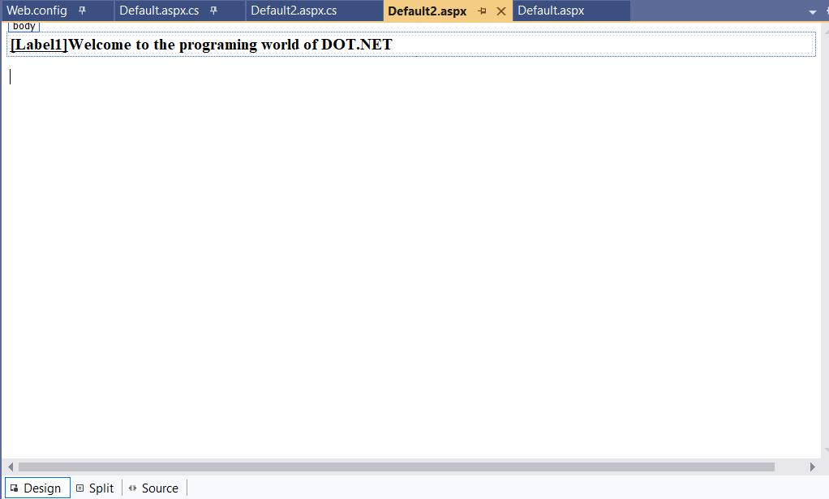

<%@ Page Language="C#" AutoEventWireup="true" CodeBehind="Default2.aspx.cs" Inherits="practical7b.Default2" %>

<!DOCTYPE html>

<html xmln[s="h](http://www.w3.org/1999/xhtml)ttp[://www.w3.org/1999/xhtml">](http://www.w3.org/1999/xhtml)

<head runat="server">

<title></title>

</head>

<body>

<form id="form1" runat="server">

<div>

<asp:Label ID="Label1" runat="server" Font-Bold="True" Font-Underline="True"></asp:Label>

<asp:Label ID="Label2" runat="server" Font-Bold="True" Text="Welcome to the programing world of DOT.NET"></asp:Label>

</div>

</form>

</body>

</html>

**Default2.aspx.cs:**

using System;

using System.Collections.Generic; using System.Linq;

using System.Web;

using System.Web.UI;

using System.Web.UI.WebControls;

namespace practical7b

{

public partial class Default2 : System.Web.UI.Page

{

protected void Page_Load(object sender, EventArgs e)

{

if (Session["Username"] != null)

{

//Response.Write(Session["Username"].ToString()); Label1.Text = Session["Username"].ToString();

} } } }

**Output:**

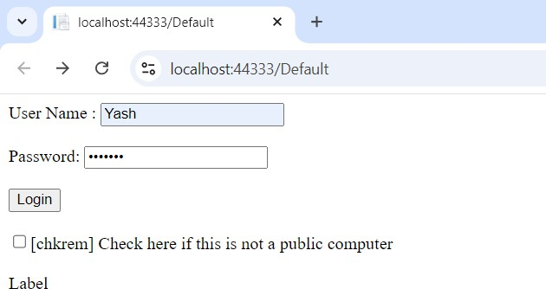

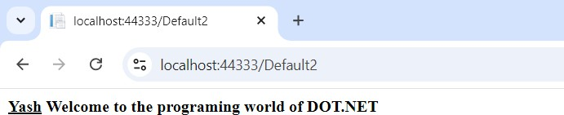

**----------------------------------------------------------------------------------------------------------------------------------------------**

## Practical 8(A)

**Aim:**

**Create a web application for inserting and deleting records from a database. (using Execute-Non Query)**

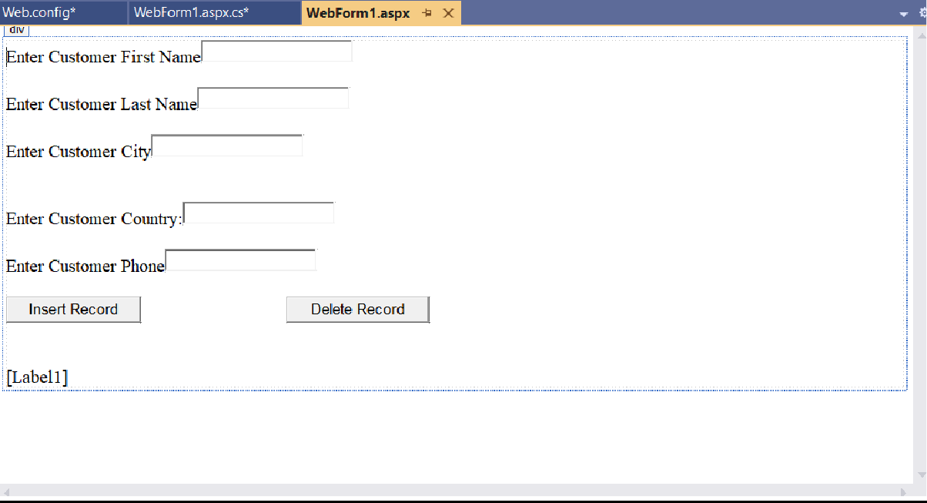

**Default.aspx:**

<%@ Page Language="C#" AutoEventWireup="true" CodeBehind="WebForm1.aspx.cs" Inherits="practical8a.WebForm1" %>

<!DOCTYPE html>

<html xmln[s="h](http://www.w3.org/1999/xhtml)ttp[://www.w3.org/1999/xhtml">](http://www.w3.org/1999/xhtml)

<head runat="server">

<title></title>

</head>

<body>

<form id="form1" runat="server">

<div>

<asp:Label ID="fname" runat="server" Text="Enter Customer First Name"></asp:Label>

<asp:TextBox ID="TextBox1" runat="server"></asp:TextBox>

<br />

<br />

<asp:Label ID="lname" runat="server" Text="Enter Customer Last Name"></asp:Label>

<asp:TextBox ID="TextBox2" runat="server"></asp:TextBox>

<br />

<br />

<asp:Label ID="city" runat="server" Text="Enter Customer City"></asp:Label>

<asp:TextBox ID="TextBox3" runat="server"></asp:TextBox>

<br />

<br />

<br />

<asp:Label ID="country" runat="server" Text="Enter Customer Country:"></asp:Label>

<asp:TextBox ID="TextBox4" runat="server"></asp:TextBox>

<br />

<br />

<asp:Label ID="phone" runat="server" Text="Enter Customer Phone"></asp:Label>

<asp:TextBox ID="TextBox5" runat="server"></asp:TextBox>

<br />

<br />

<asp:Button ID="Button1" runat="server" OnClick="Button1_Click" Text="Insert Record" /> &nbsp;&nbsp;&nbsp;&nbsp;&nbsp;&nbsp;&nbsp;&nbsp;&nbsp;&nbsp;&nbsp;&nbsp;&nbsp;&nbsp;&nbsp

;&nbsp;&nbsp;&nbsp;&nbsp;&nbsp;&nbsp;&nbsp;&nbsp;&nbsp;&nbsp;&nbsp;&nbsp;&nbsp;&nbsp;&nbs p;&nbsp;

<asp:Button ID="Button2" runat="server" OnClick="Button2_Click" Text="Delete Record" />

<br />

<br />

<br />

<asp:Label ID="Label1" runat="server"></asp:Label>

</div>

</form>

</body>

</html>

**Default.aspx.cs:**

using System;

using System.Collections.Generic; using System.Configuration;

using System.Data.SqlClient; using System.Drawing; using System.Linq;

using System.Security.Policy; using System.Web;

using System.Web.UI;

using System.Web.UI.WebControls;

namespace practical8a

{

public partial class WebForm1 : System.Web.UI.Page

{

protected void Page_Load(object sender, EventArgs e)

{

}

protected void Button1_Click(object sender, EventArgs e)

{

string connStr = ConfigurationManager.ConnectionStrings["connStr"].ConnectionString;

SqlConnection con=new SqlConnection(connStr);

string InsertQuery = "insert into customer values(@fname, @lname, @city,country, @phone)";

SqlCommand cmd = new SqlCommand(InsertQuery, con);

cmd.Parameters.AddWithValue("@fname", TextBox1.Text);

cmd.Parameters.AddWithValue("@lname", TextBox2.Text);

cmd.Parameters.AddWithValue("@city", TextBox3.Text);

cmd.Parameters.AddWithValue("@country", TextBox4.Text);

cmd.Parameters.AddWithValue("@phone", TextBox5.Text);

con.Open();

Label1.Text ="Record Inserted Successfuly.";

con.Close();

}

protected void Button2_Click(object sender, EventArgs e)

{

string connStr = ConfigurationManager.ConnectionStrings ["connStr"].ConnectionString;

SqlConnection con =new SqlConnection(connStr);

string InsertQuery = "delete from customer where FirstName=@fname";

SqlCommand cmd = new SqlCommand(InsertQuery, con);

cmd.Parameters.AddWithValue("@fname", TextBox1.Text);

con.Open();

cmd.ExecuteNonQuery();

Label1.Text= "Record Deleted Successfuly."; con.Close();

}

}

}

**Output:**

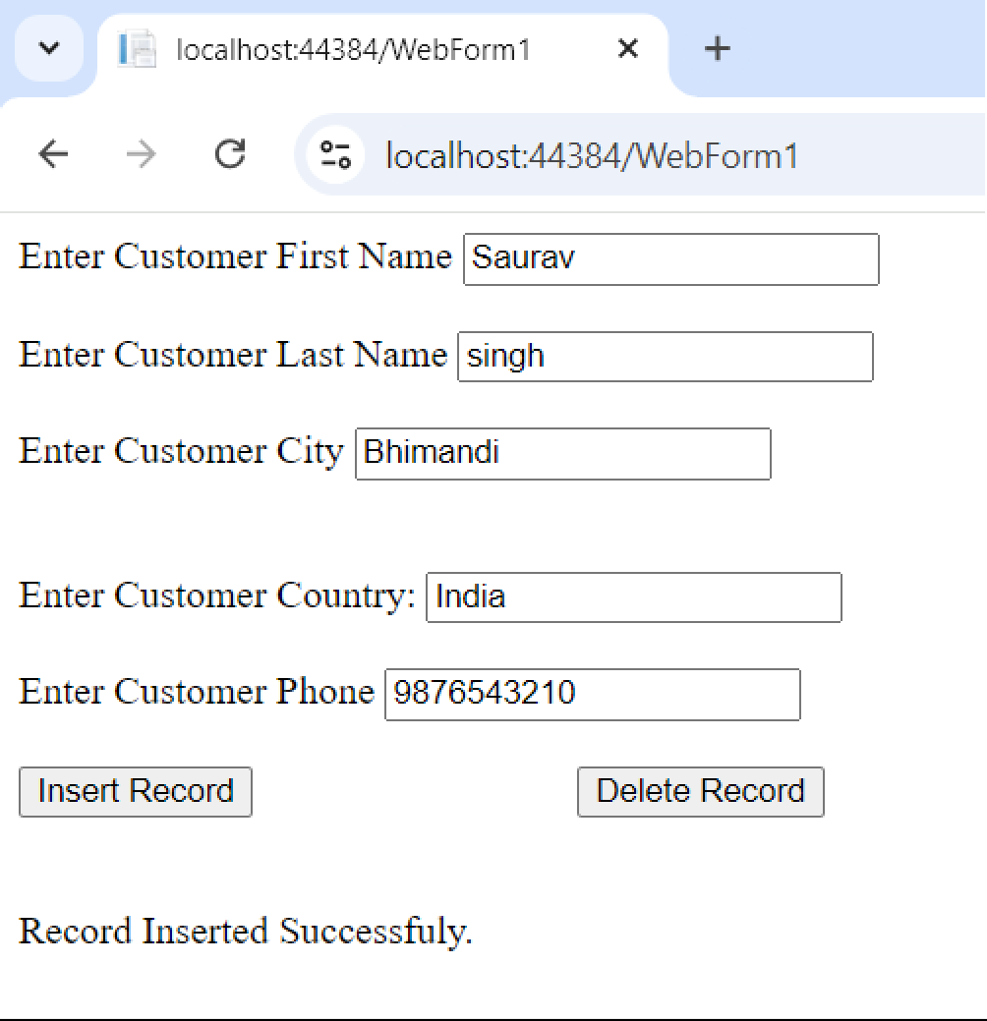

**----------------------------------------------------------------------------------------------------------------------------------------------**

## Practical 8(B)

**Aim:**

**Create a web application for user defined exception handling.**

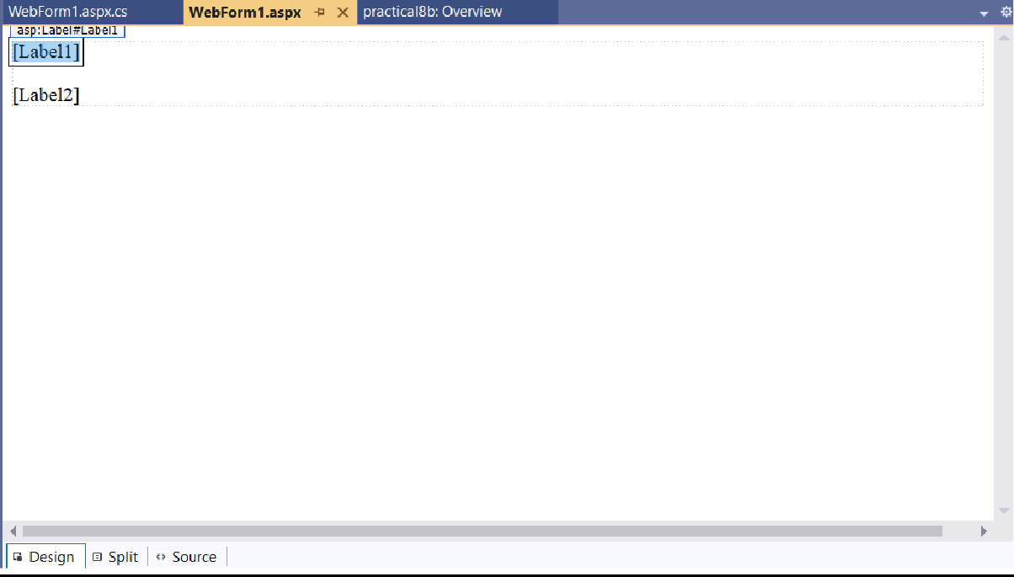

**Default.aspx:**

<%@ Page Language="C#" AutoEventWireup="true" CodeBehind="WebForm1.aspx.cs" Inherits="practical8b.WebForm1" %>

<!DOCTYPE html>

<html xmln[s="h](http://www.w3.org/1999/xhtml)ttp[://www.w3.org/1999/xhtml">](http://www.w3.org/1999/xhtml)

<head runat="server">

<title></title>

</head>

<body>

<form id="form1" runat="server">

<div>

<asp:Label ID="Label1" runat="server" Text=""></asp:Label>

<br />

<br />

<asp:Label ID="Label2" runat="server" Text=""></asp:Label>

</div>

</form>

</body>

</html>

**Default.aspx.cs:**

using System;

using System.Collections.Generic; using System.Linq;

using System.Reflection.Emit; using System.Web;

using System.Web.UI;

using System.Web.UI.WebControls;

namespace practical8b

{

public partial class WebForm1 : System.Web.UI.Page

{

protected void Page_Load(object sender, EventArgs e)

{

try

{

throw new UserDefinedException("New User Defined Exception");

}

catch (Exception ex)

{

Label1.Text = "Exception caught here" +ex.ToString();

}

Label2.Text = "Final Statement that is executed";

}

class UserDefinedException:Exception

{

public UserDefinedException(string str)

{

Console.WriteLine("User defined exception");

}

}

class HandledException

{

public static void Main()

{

}

}

}

}

**Output:**

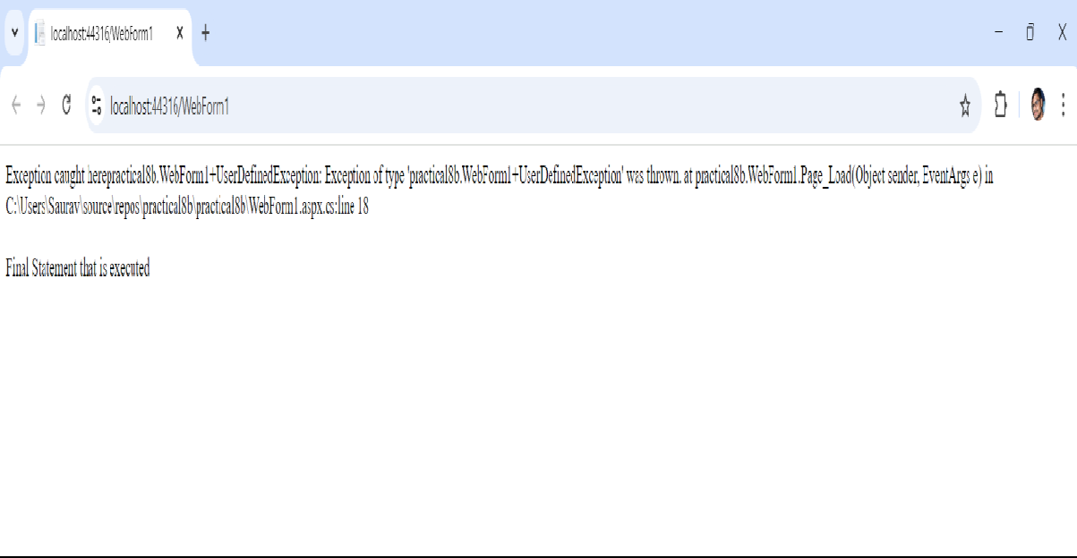

**----------------------------------------------------------------------------------------------------------------------------------------------**

## Practical 9(A)

**Aim:**

**Create a web application to demonstrate use of GridView buttons column and GridView events along with paging and sorting.**

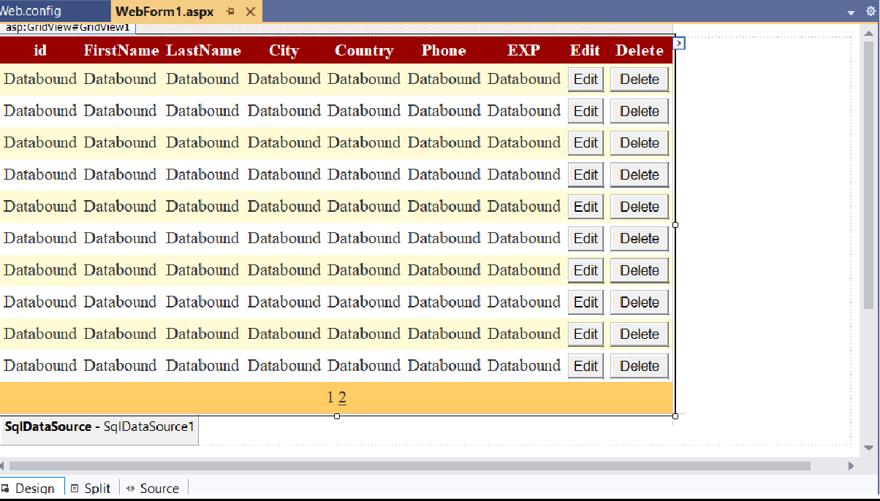

**Default.aspx:**

<%@ Page Language="C#" AutoEventWireup="true" CodeBehind="WebForm1.aspx.cs" Inherits="practical9a.WebForm1" %>

<!DOCTYPE html>

<html xmln[s="h](http://www.w3.org/1999/xhtml)ttp[://www.w3.org/1999/xhtml">](http://www.w3.org/1999/xhtml)

<head runat="server">

<title></title>

</head>

<body>

<form id="form1" runat="server">

<div>

<asp:GridView ID="GridView1" runat="server" AllowPaging="True" AutoGenerateColumns="False" CellPadding="4" DataKeyNames="id" DataSourceID="SqlDataSource1" ForeColor="#333333" GridLines="None">

<AlternatingRowStyle BackColor="White" />

<Columns>

<asp:BoundField DataField="id" HeaderText="id" ReadOnly="True" SortExpression="id" />

<asp:BoundField DataField="FirstName" HeaderText="FirstName" SortExpression="FirstName" />

<asp:BoundField DataField="LastName" HeaderText="LastName" SortExpression="LastName" />

<asp:BoundField DataField="City" HeaderText="City" SortExpression="City" />

<asp:BoundField DataField="Country" HeaderText="Country" SortExpression="Country" />

<asp:BoundField DataField="Phone" HeaderText="Phone" SortExpression="Phone" />

<asp:BoundField DataField="EXP" HeaderText="EXP" SortExpression="EXP" />

<asp:CommandField ButtonType="Button" HeaderText="Edit" ShowEditButton="True" ShowHeader="True"

/>

<asp:CommandField ButtonType="Button" HeaderText="Delete" ShowDeleteButton="True" ShowHeader="True" />

</Columns>

<FooterStyle BackColor="#990000" Font-Bold="True" ForeColor="White" />

<HeaderStyle BackColor="#990000" Font-Bold="True" ForeColor="White" />

<PagerStyle BackColor="#FFCC66" ForeColor="#333333" HorizontalAlign="Center" />

<RowStyle BackColor="#FFFBD6" ForeColor="#333333" />

<SelectedRowStyle BackColor="#FFCC66" Font-Bold="True" ForeColor="Navy" />

<SortedAscendingCellStyle BackColor="#FDF5AC" />

<SortedAscendingHeaderStyle BackColor="#4D0000" />

<SortedDescendingCellStyle BackColor="#FCF6C0" />

<SortedDescendingHeaderStyle BackColor="#820000" />

</asp:GridView>

<asp:SqlDataSource ID="SqlDataSource1" runat="server" ConflictDetection="CompareAllValues" ConnectionString="<%$ ConnectionStrings:businessConnectionString2 %>" DeleteCommand="DELETE

FROM [customer] WHERE [id] = @original_id AND [FirstName] = @original_FirstName AND [LastName] = @original_LastName AND (([City] = @original_City) OR ([City] IS NULL AND @original_City IS NULL)) AND (([Country] = @original_Country) OR ([Country] IS NULL AND @original_Country IS NULL)) AND (([Phone] = @original_Phone) OR ([Phone] IS NULL AND @original_Phone IS NULL)) AND (([EXP] = @original_EXP) OR ([EXP] IS NULL AND @original_EXP IS NULL))" InsertCommand="INSERT INTO [customer] ([id], [FirstName], [LastName], [City], [Country], [Phone], [EXP]) VALUES (@id, @FirstName, @LastName, @City, @Country, @Phone, @EXP)" OldValuesParameterFormatString="original_{0}" SelectCommand="SELECT * FROM [customer]" UpdateCommand="UPDATE [customer] SET [FirstName] = @FirstName, [LastName] = @LastName, [City] = @City, [Country] = @Country, [Phone] = @Phone, [EXP] = @EXP WHERE [id] =

@original_id AND [FirstName] = @original_FirstName AND [LastName] = @original_LastName AND (([City]

= @original_City) OR ([City] IS NULL AND @original_City IS NULL)) AND (([Country] = @original_Country)

OR ([Country] IS NULL AND @original_Country IS NULL)) AND (([Phone] = @original_Phone) OR ([Phone] IS NULL AND @original_Phone IS NULL)) AND (([EXP] = @original_EXP) OR ([EXP] IS NULL AND @original_EXP IS NULL))" ProviderName="<%$ ConnectionStrings:businessConnectionString2.ProviderName %>">

<DeleteParameters>

<asp:Parameter Name="original_id" Type="Int32" />

<asp:Parameter Name="original_FirstName" Type="String" />

<asp:Parameter Name="original_LastName" Type="String" />

<asp:Parameter Name="original_City" Type="String" />

<asp:Parameter Name="original_Country" Type="String" />

<asp:Parameter Name="original_Phone" Type="String" />

<asp:Parameter Name="original_EXP" Type="String" />

</DeleteParameters>

<InsertParameters>

<asp:Parameter Name="id" Type="Int32" />

<asp:Parameter Name="FirstName" Type="String" />

<asp:Parameter Name="LastName" Type="String" />

<asp:Parameter Name="City" Type="String" />

<asp:Parameter Name="Country" Type="String" />

<asp:Parameter Name="Phone" Type="String" />

<asp:Parameter Name="EXP" Type="String" />

</InsertParameters>

<UpdateParameters>

<asp:Parameter Name="FirstName" Type="String" />

<asp:Parameter Name="LastName" Type="String" />

<asp:Parameter Name="City" Type="String" />

<asp:Parameter Name="Country" Type="String" />

<asp:Parameter Name="Phone" Type="String" />

<asp:Parameter Name="EXP" Type="String" />

<asp:Parameter Name="original_id" Type="Int32" />

<asp:Parameter Name="original_FirstName" Type="String" />

<asp:Parameter Name="original_LastName" Type="String" />

<asp:Parameter Name="original_City" Type="String" />

<asp:Parameter Name="original_Country" Type="String" />

<asp:Parameter Name="original_Phone" Type="String" />

<asp:Parameter Name="original_EXP" Type="String" />

</UpdateParameters>

</asp:SqlDataSource>

</div>

</form>

</body>

</html>

**Output:**

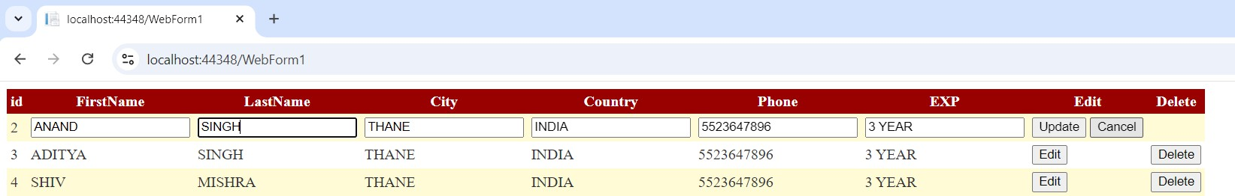

## Practical 9(B)

**Aim:**

**Create a web application to demonstrate data binding using DetailsView and FormView Control.**

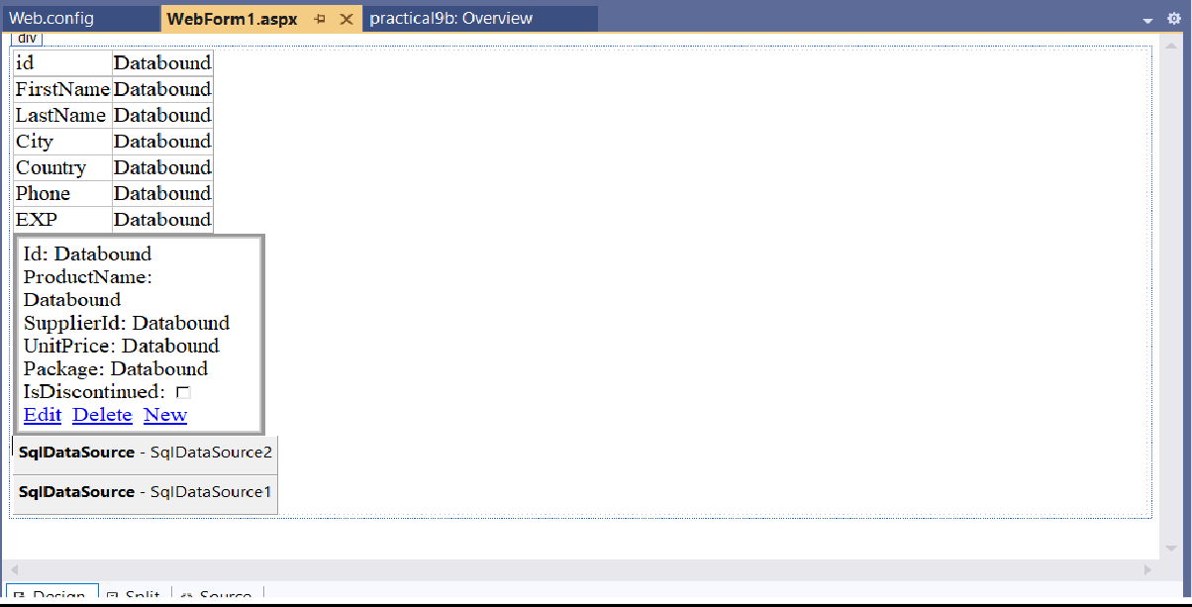

**Default.aspx:**

<%@ Page Language="C#" AutoEventWireup="true" CodeBehind="WebForm1.aspx.cs" Inherits="practical9b.WebForm1" %>

<!DOCTYPE html>

<html xmln[s="h](http://www.w3.org/1999/xhtml)ttp[://www.w3.org/1999/xhtml">](http://www.w3.org/1999/xhtml)

<head runat="server">

<title></title>

</head>

<body>

<form id="form1" runat="server">

<div>

<asp:DetailsView ID="DetailsView1" runat="server" AutoGenerateRows="False" DataKeyNames="id" DataSourceID="SqlDataSource1" Height="50px" Width="125px">

<Fields>

<asp:BoundField DataField="id" HeaderText="id" ReadOnly="True" SortExpression="id" />

<asp:BoundField DataField="FirstName" HeaderText="FirstName" SortExpression="FirstName" />

<asp:BoundField DataField="LastName" HeaderText="LastName" SortExpression="LastName" />

<asp:BoundField DataField="City" HeaderText="City" SortExpression="City" />

<asp:BoundField DataField="Country" HeaderText="Country" SortExpression="Country" />

<asp:BoundField DataField="Phone" HeaderText="Phone" SortExpression="Phone" />

<asp:BoundField DataField="EXP" HeaderText="EXP" SortExpression="EXP" />

</Fields>

</asp:DetailsView> &nbsp;&nbsp;&nbsp;&nbsp;&nbsp;

<asp:FormView ID="FormView1" runat="server" BackColor="#CCCCCC" BorderColor="#999999" BorderStyle="Solid" BorderWidth="3px" CellPadding="4" CellSpacing="2" DataKeyNames="Id" DataSourceID="SqlDataSource2" ForeColor="Black" GridLines="Both" Width="220px">

<EditItemTemplate>

Id:

<asp:Label ID="IdLabel1" runat="server" Text='<%# Eval("Id") %>' />

<br />

ProductName:

<asp:TextBox ID="ProductNameTextBox" runat="server" Text='<%# Bind("ProductName") %>' />

<br />

SupplierId:

<asp:TextBox ID="SupplierIdTextBox" runat="server" Text='<%# Bind("SupplierId") %>' />

<br />

UnitPrice:

<asp:TextBox ID="UnitPriceTextBox" runat="server" Text='<%# Bind("UnitPrice") %>' />

<br />

Package:

<asp:TextBox ID="PackageTextBox" runat="server" Text='<%# Bind("Package") %>' />

<br />

IsDiscontinued:

<asp:CheckBox ID="IsDiscontinuedCheckBox" runat="server" Checked='<%# Bind("IsDiscontinued") %>' />

<br />

<asp:LinkButton ID="UpdateButton" runat="server" CausesValidation="True" CommandName="Update" Text="Update" />

&nbsp;<asp:LinkButton ID="UpdateCancelButton" runat="server" CausesValidation="False" CommandName="Cancel" Text="Cancel" />

</EditItemTemplate>

<EditRowStyle BackColor="#000099" Font-Bold="True" ForeColor="White" />

<FooterStyle BackColor="#CCCCCC" />

<HeaderStyle BackColor="Black" Font-Bold="True" ForeColor="White" />

<InsertItemTemplate>

Id:

<asp:TextBox ID="IdTextBox" runat="server" Text='<%# Bind("Id") %>' />

<br />

ProductName:

<asp:TextBox ID="ProductNameTextBox" runat="server" Text='<%# Bind("ProductName") %>' />

<br />

SupplierId:

<asp:TextBox ID="SupplierIdTextBox" runat="server" Text='<%# Bind("SupplierId") %>' />

<br />

UnitPrice:

<asp:TextBox ID="UnitPriceTextBox" runat="server" Text='<%# Bind("UnitPrice") %>' />

<br />

Package:

<asp:TextBox ID="PackageTextBox" runat="server" Text='<%# Bind("Package") %>' />

<br />

IsDiscontinued:

<asp:CheckBox ID="IsDiscontinuedCheckBox" runat="server" Checked='<%# Bind("IsDiscontinued") %>' />

<br />

<asp:LinkButton ID="InsertButton" runat="server" CausesValidation="True" CommandName="Insert" Text="Insert" />

&nbsp;<asp:LinkButton ID="InsertCancelButton" runat="server" CausesValidation="False" CommandName="Cancel" Text="Cancel" />

</InsertItemTemplate>

<ItemTemplate>

Id:

<asp:Label ID="IdLabel" runat="server" Text='<%# Eval("Id") %>' />

<br />

ProductName:

<asp:Label ID="ProductNameLabel" runat="server" Text='<%# Bind("ProductName") %>' />

<br />

SupplierId:

<asp:Label ID="SupplierIdLabel" runat="server" Text='<%# Bind("SupplierId") %>' />

<br />

UnitPrice:

<asp:Label ID="UnitPriceLabel" runat="server" Text='<%# Bind("UnitPrice") %>' />

<br />

Package:

<asp:Label ID="PackageLabel" runat="server" Text='<%# Bind("Package") %>' />

<br />

IsDiscontinued:

<asp:CheckBox ID="IsDiscontinuedCheckBox" runat="server" Checked='<%# Bind("IsDiscontinued") %>' Enabled="false" />

<br />

<asp:LinkButton ID="EditButton" runat="server" CausesValidation="False" CommandName="Edit" Text="Edit" />

&nbsp;<asp:LinkButton ID="DeleteButton" runat="server" CausesValidation="False" CommandName="Delete" Text="Delete" />

&nbsp;<asp:LinkButton ID="NewButton" runat="server" CausesValidation="False" CommandName="New" Text="New" />

</ItemTemplate>

<PagerStyle BackColor="#CCCCCC" ForeColor="Black" HorizontalAlign="Left" />

<RowStyle BackColor="White" />

</asp:FormView>

<asp:SqlDataSource ID="SqlDataSource2" runat="server" ConflictDetection="CompareAllValues" ConnectionString="<%$ ConnectionStrings:businessConnectionString2 %>" DeleteCommand="DELETE FROM [Product] WHERE [Id] = @original_Id AND [ProductName] = @original_ProductName AND

[SupplierId] = @original_SupplierId AND (([UnitPrice] = @original_UnitPrice) OR ([UnitPrice] IS NULL AND @original_UnitPrice IS NULL)) AND (([Package] = @original_Package) OR ([Package] IS NULL AND

@original_Package IS NULL)) AND [IsDiscontinued] = @original_IsDiscontinued" InsertCommand="INSERT INTO [Product] ([Id], [ProductName], [SupplierId], [UnitPrice], [Package], [IsDiscontinued]) VALUES (@Id, @ProductName, @SupplierId, @UnitPrice, @Package, @IsDiscontinued)"

OldValuesParameterFormatString="original_{0}" ProviderName="<%$

ConnectionStrings:businessConnectionString2.ProviderName %>" SelectCommand="SELECT * FROM

[Product]" UpdateCommand="UPDATE [Product] SET [ProductName] = @ProductName, [SupplierId] = @SupplierId, [UnitPrice] = @UnitPrice, [Package] = @Package, [IsDiscontinued] = @IsDiscontinued WHERE [Id] = @original_Id AND [ProductName] = @original_ProductName AND [SupplierId] = @original_SupplierId AND (([UnitPrice] = @original_UnitPrice) OR ([UnitPrice] IS NULL AND @original_UnitPrice IS NULL)) AND (([Package] = @original_Package) OR ([Package] IS NULL AND @original_Package IS NULL)) AND

[IsDiscontinued] = @original_IsDiscontinued">

<DeleteParameters>

<asp:Parameter Name="original_Id" Type="Int32" />

<asp:Parameter Name="original_ProductName" Type="String" />

<asp:Parameter Name="original_SupplierId" Type="String" />

<asp:Parameter Name="original_UnitPrice" Type="Decimal" />

<asp:Parameter Name="original_Package" Type="String" />

<asp:Parameter Name="original_IsDiscontinued" Type="Boolean" />

</DeleteParameters>

<InsertParameters>

<asp:Parameter Name="Id" Type="Int32" />

<asp:Parameter Name="ProductName" Type="String" />

<asp:Parameter Name="SupplierId" Type="String" />

<asp:Parameter Name="UnitPrice" Type="Decimal" />

<asp:Parameter Name="Package" Type="String" />

<asp:Parameter Name="IsDiscontinued" Type="Boolean" />

</InsertParameters>

<UpdateParameters>

<asp:Parameter Name="ProductName" Type="String" />

<asp:Parameter Name="SupplierId" Type="String" />

<asp:Parameter Name="UnitPrice" Type="Decimal" />

<asp:Parameter Name="Package" Type="String" />

<asp:Parameter Name="IsDiscontinued" Type="Boolean" />

<asp:Parameter Name="original_Id" Type="Int32" />

<asp:Parameter Name="original_ProductName" Type="String" />

<asp:Parameter Name="original_SupplierId" Type="String" />

<asp:Parameter Name="original_UnitPrice" Type="Decimal" />

<asp:Parameter Name="original_Package" Type="String" />

<asp:Parameter Name="original_IsDiscontinued" Type="Boolean" />

</UpdateParameters>

</asp:SqlDataSource>

<asp:SqlDataSource ID="SqlDataSource1" runat="server" ConflictDetection="CompareAllValues"

ConnectionString="<%$ ConnectionStrings:businessConnectionString %>" DeleteCommand="DELETE FROM [customer] WHERE [id] = @original_id AND [FirstName] = @original_FirstName AND [LastName] =

@original_LastName AND (([City] = @original_City) OR ([City] IS NULL AND @original_City IS NULL)) AND

(([Country] = @original_Country) OR ([Country] IS NULL AND @original_Country IS NULL)) AND (([Phone] = @original_Phone) OR ([Phone] IS NULL AND @original_Phone IS NULL)) AND (([EXP] = @original_EXP) OR ([EXP] IS NULL AND @original_EXP IS NULL))" InsertCommand="INSERT INTO [customer] ([id], [FirstName], [LastName], [City], [Country], [Phone], [EXP]) VALUES (@id, @FirstName, @LastName, @City, @Country, @Phone, @EXP)" OldValuesParameterFormatString="original_{0}" ProviderName="<%$

ConnectionStrings:businessConnectionString.ProviderName %>" SelectCommand="SELECT * FROM [customer]" UpdateCommand="UPDATE [customer] SET [FirstName] = @FirstName, [LastName] = @LastName, [City] = @City, [Country] = @Country, [Phone] = @Phone, [EXP] = @EXP WHERE [id] =

@original_id AND [FirstName] = @original_FirstName AND [LastName] = @original_LastName AND (([City]

= @original_City) OR ([City] IS NULL AND @original_City IS NULL)) AND (([Country] = @original_Country)

OR ([Country] IS NULL AND @original_Country IS NULL)) AND (([Phone] = @original_Phone) OR ([Phone] IS NULL AND @original_Phone IS NULL)) AND (([EXP] = @original_EXP) OR ([EXP] IS NULL AND @original_EXP IS NULL))">

<DeleteParameters>

<asp:Parameter Name="original_id" Type="Int32" />

<asp:Parameter Name="original_FirstName" Type="String" />

<asp:Parameter Name="original_LastName" Type="String" />

<asp:Parameter Name="original_City" Type="String" />

<asp:Parameter Name="original_Country" Type="String" />

<asp:Parameter Name="original_Phone" Type="String" />

<asp:Parameter Name="original_EXP" Type="String" />

</DeleteParameters>

<InsertParameters>

<asp:Parameter Name="id" Type="Int32" />

<asp:Parameter Name="FirstName" Type="String" />

<asp:Parameter Name="LastName" Type="String" />

<asp:Parameter Name="City" Type="String" />

<asp:Parameter Name="Country" Type="String" />

<asp:Parameter Name="Phone" Type="String" />

<asp:Parameter Name="EXP" Type="String" />

</InsertParameters>

<UpdateParameters>

<asp:Parameter Name="FirstName" Type="String" />

<asp:Parameter Name="LastName" Type="String" />

<asp:Parameter Name="City" Type="String" />

<asp:Parameter Name="Country" Type="String" />

<asp:Parameter Name="Phone" Type="String" />

<asp:Parameter Name="EXP" Type="String" />

<asp:Parameter Name="original_id" Type="Int32" />

<asp:Parameter Name="original_FirstName" Type="String" />

<asp:Parameter Name="original_LastName" Type="String" />

<asp:Parameter Name="original_City" Type="String" />

<asp:Parameter Name="original_Country" Type="String" />

<asp:Parameter Name="original_Phone" Type="String" />

<asp:Parameter Name="original_EXP" Type="String" />

</UpdateParameters>

</asp:SqlDataSource>

</div>

</form>

</body>

</html>

**Output:**

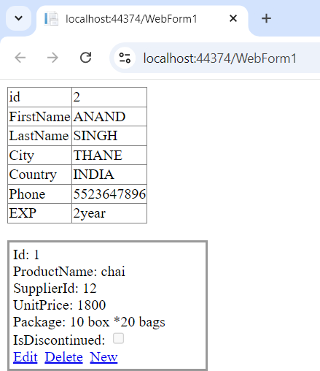

**----------------------------------------------------------------------------------------------------------------------------------------------**

## Practical 10(A)

**Aim:**

**Create a web application to demonstrate JB Bootstrap Button.**

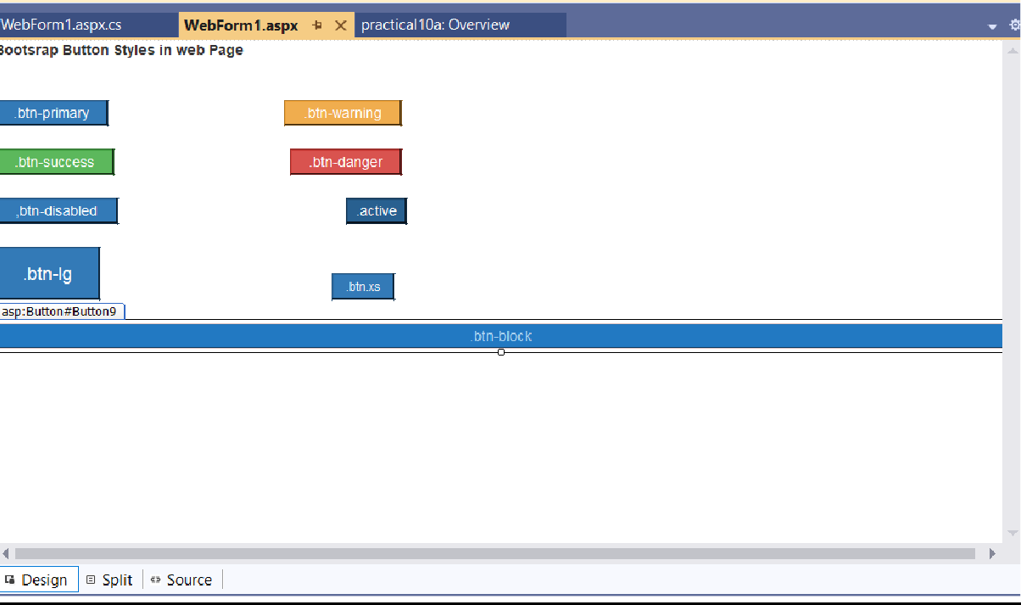

**Default.aspx:**

<%@ Page Language="C#" AutoEventWireup="true" CodeBehind="WebForm1.aspx.cs" Inherits="practical10a.WebForm1" %>

<!DOCTYPE html>

<html xmln[s="h](http://www.w3.org/1999/xhtml)ttp[://www.w3.org/1999/xhtml">](http://www.w3.org/1999/xhtml)

<head runat="server">

<title>Bootstrap example</title>

<meta charset="utf-8">

<meta name="viewport" content="width=device-width, initial-scale=1">

<link rel="stylesheet" href= "https://maxcdn.bootstrapcdn.com

/bootstrap/3.4.1/css/bootstrap.min.css">

<script

src="https://ajax.googleapis.com/ajax/libs/jquery/3.7.1/jquery.min.js">

</script>

<script src="https://maxcdn.bootstrapcdn.com/bootstrap/3.4.1/js/bootstrap.min.js">

</script>

</head>

<body>

<form id="form1" runat="server">

<div>

<strong>Bootsrap Button Styles in web Page<br />

<br />

</strong>

</div>

<asp:Button ID="Button1" runat="server" CssClass="btn-primary" Text=".btn-primary" />

<asp:Button ID="Button2" runat="server" CssClass="btn-warning" Text=".btn-warning" />

<br />

<br />

<asp:Button ID="Button4" runat="server" CssClass="btn-danger" Text=".btn-danger" Width="112px" />

<br />

<br />

<asp:Button ID="Button5" runat="server" CssClass="btn-primary disabled" Text=",btn-disabled" />

<asp:Button ID="Button6" runat="server" CssClass="btn-primary active" Text=".active" />

<br />

<br />

<asp:Button ID="Button7" runat="server" CssClass="btn-primary btn-lg" Text=".btn-lg" />

<asp:Button ID="Button8" runat="server" Text=".btn.xs" CssClass="btn-primary btn-xs" />

<br />

<br />

<asp:Button ID="Button9" runat="server" Text=".btn-block" CssClass="btn-primary btn-block" />

</form>

</body>

</html>

**Output:**

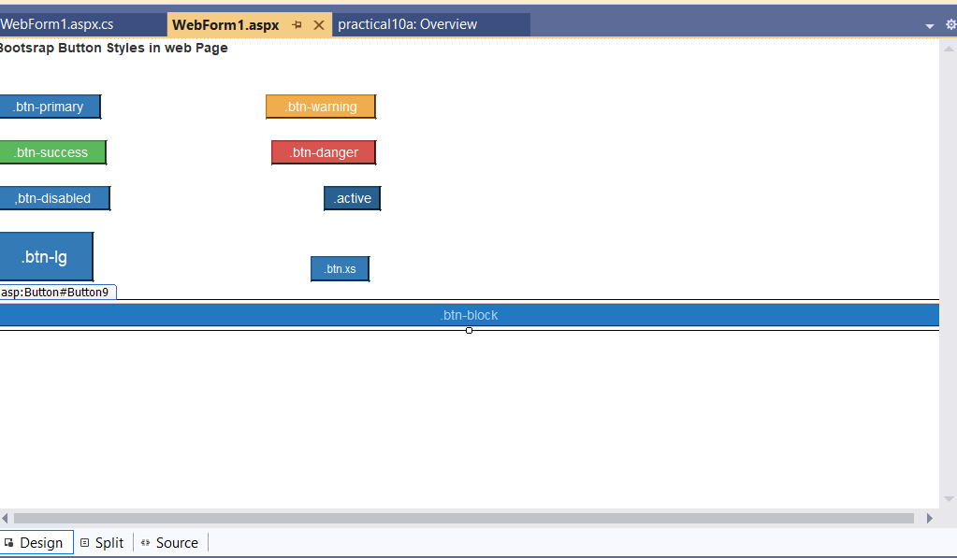

**----------------------------------------------------------------------------------------------------------------------------------------------**

## Practical 10(B)

**Aim:**

**Create a web application to demonstrate use of various Ajax control**

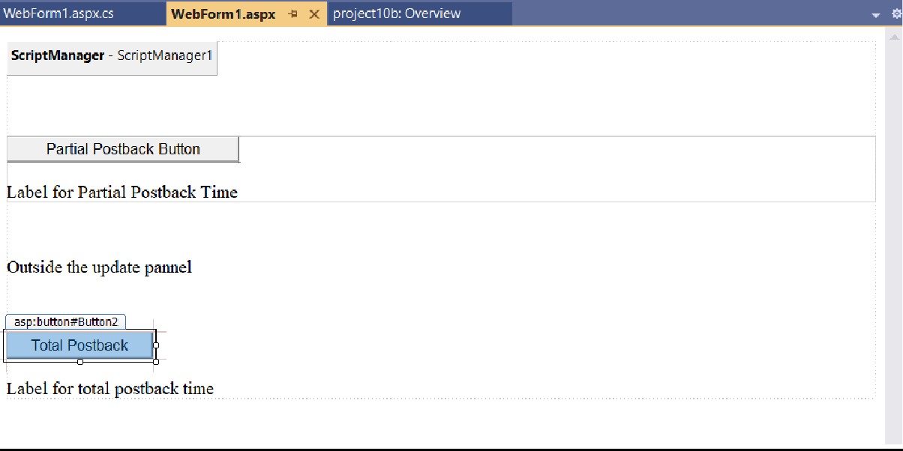

**Default.aspx:**

<%@ Page Language="C#" AutoEventWireup="true" CodeBehind="WebForm1.aspx.cs" Inherits="project10b.WebForm1" %>

<!DOCTYPE html>

<html xmln[s="h](http://www.w3.org/1999/xhtml)ttp[://www.w3.org/1999/xhtml">](http://www.w3.org/1999/xhtml)

<head runat="server">

<title></title>

</head>

<body>

<form id="form1" runat="server">

<div>

<asp:ScriptManager ID="ScriptManager1" runat="server">

</asp:ScriptManager>

<br />

<br />

<asp:UpdatePanel ID="UpdatePanel1" runat="server">

<ContentTemplate>

<asp:Button ID="Button1" runat="server" OnClick="Button1_Click" Text="Partial Postback Button" />

<br />

<br />

<asp:Label ID="Label1" runat="server" Text="Label for Partial Postback Time"></asp:Label>

</ContentTemplate>

</asp:UpdatePanel>

</div>

<p> &nbsp;</p>

<p>

<asp:Label ID="Label3" runat="server" Text="Outside the update pannel"></asp:Label>

</p>

<p> &nbsp;</p>

<asp:Button ID="Button2" runat="server" OnClick="Button2_Click" Text="Total Postback" />

<br />

<br />

<asp:Label ID="Label2" runat="server" Text="Label for total postback time"></asp:Label>

</form>

</body>

</html>

**Default.aspx.cs:**

using System;

using System.Collections.Generic; using System.Linq;

using System.Web; using System.Web.UI;

using System.Web.UI.WebControls;

namespace project10b

{

public partial class WebForm1 : System.Web.UI.Page

{

protected void Page_Load(object sender, EventArgs e)

{

}

protected void Button1_Click(object sender, EventArgs e)

{

string time =DateTime.Now.ToLongTimeString(); Label1.Text = "Showing time from panel" + time;

Label2.Text = "Showing time from outside" + time;

}

protected void Button2_Click(object sender, EventArgs e)

{

string time = DateTime.Now.ToLongTimeString(); Label1.Text = "Showing time from panel" + time;

Label2.Text = "Showing time from outside" + time;

}

}

}

**Output:**

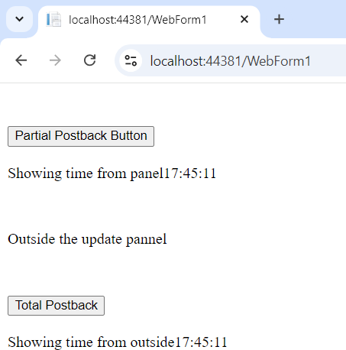

**----------------------------------------------------------------------------------------------------------------------------------------------**

## Practical 10c

**Aim:**

**Create a web application to demonstrate Installation and use of NuGet package.**

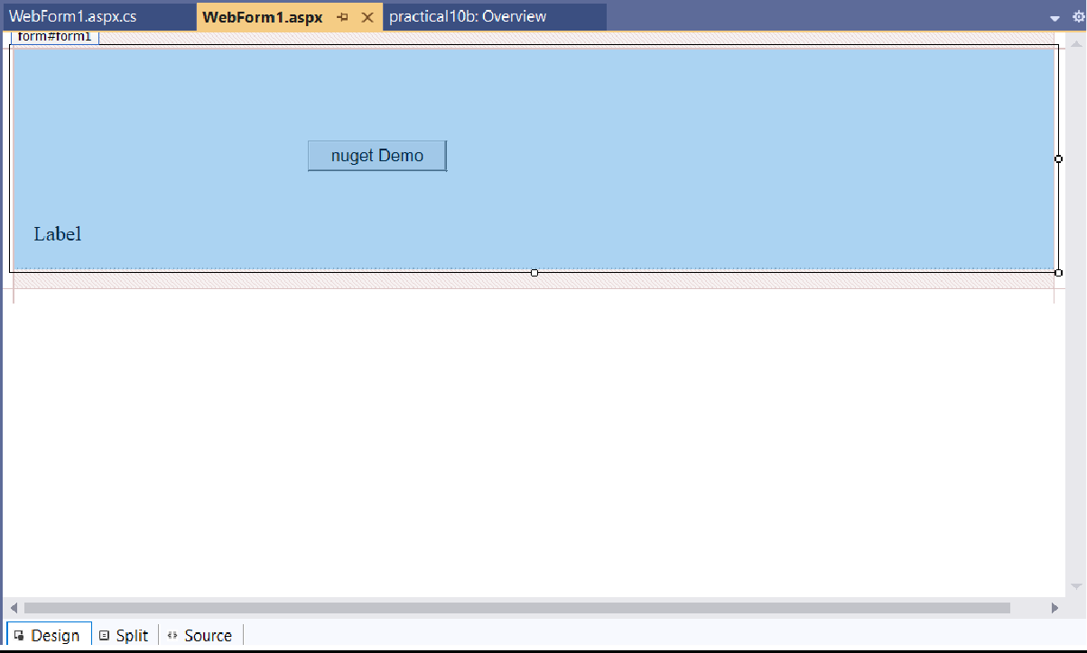

**Default.aspx:**

<%@ Page Language="C#" AutoEventWireup="true" CodeBehind="WebForm1.aspx.cs" Inherits="practical10b.WebForm1" %>

<!DOCTYPE html>

<html xmln[s="h](http://www.w3.org/1999/xhtml)ttp[://www.w3.org/1999/xhtml">](http://www.w3.org/1999/xhtml)

<head runat="server">

<title></title>

</head>

<body>

<form id="form1" runat="server">

<div>

<br />

<br />

<br />

<br />

<asp:Button ID="Button1" runat="server" OnClick="Button1_Click" Text="nuget Demo" />

<br />

<br />

<br /> &nbsp;&nbsp;&nbsp;

<asp:Label ID="Label1" runat="server" Font-Bold="False" Text="Label"></asp:Label>

<br />

</div>

</form>

</body>

</html>

**Default.aspx.cs:**

using Newtonsoft.Json; using System;

using System.Collections.Generic; using System.Linq;

using System.Reflection.Emit; using System.Security.Principal; using System.Web;

using System.Web.UI;

using System.Web.UI.WebControls;

namespace practical10b

{

public partial class WebForm1 : System.Web.UI.Page

{

protected void Page_Load(object sender, EventArgs e)

{

}

protected void Button1_Click(object sender, EventArgs e)

{

Account account = new Account

{

Name = "saurav singh",

Email = ["sks@](mailto:sks@microsoft.com)m[icrosoft.com](mailto:sks@microsoft.com)",

DOB = new DateTime(1982, 12, 13, 0, 0, 0, DateTimeKind.Local),

};

string json =

JsonConvert.SerializeObject(account, Newtonsoft.Json.Formatting.Indented); Label1.Text = json;

}

}

public class Account // Ensure this class is defined

{

public string Name { get; set; } public string Email { get; set; } public DateTime DOB { get; set; }

}}

**Output:**





